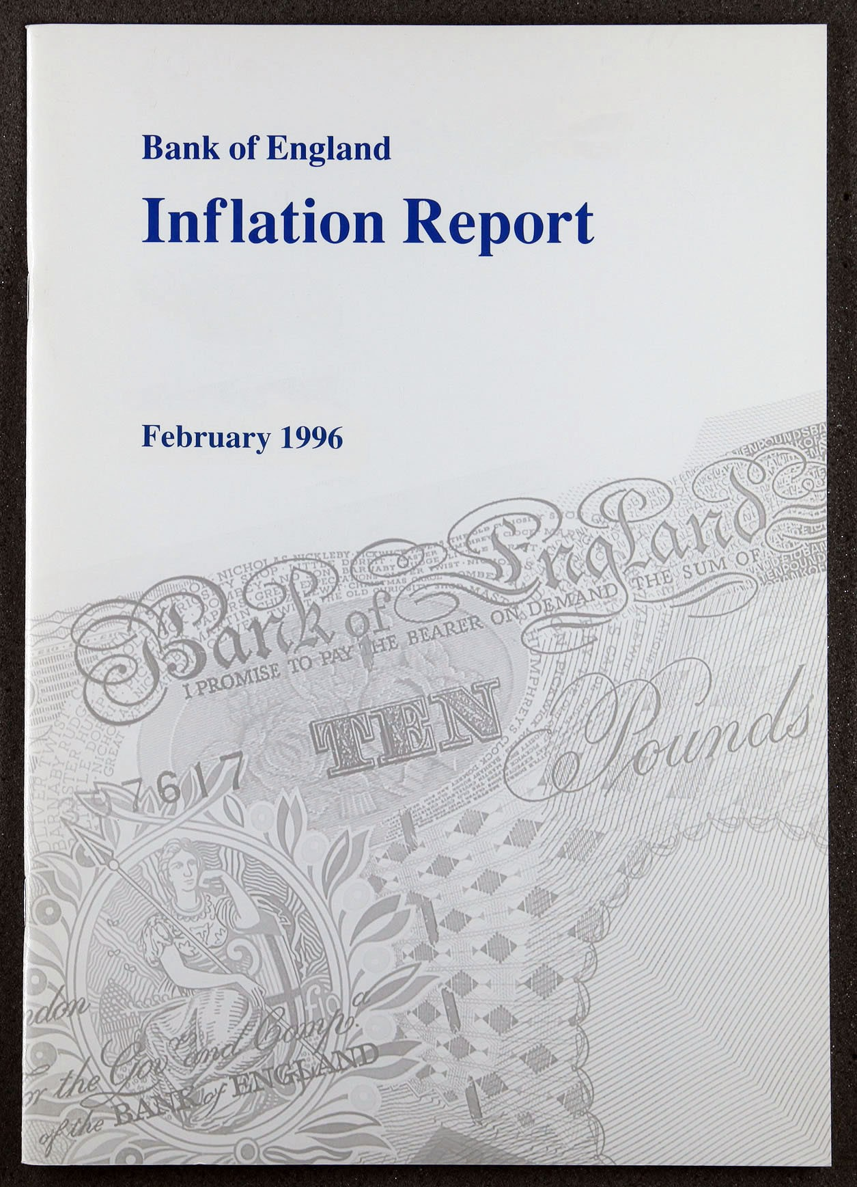

Inflation Report

February 1996

Summary

Recent developments in inflation

.I Retail prices measures Expenditure deflators Summary

Moncy and interest rates

* 1. Money and credit aggregates Narrow money

Broad money Credit demand Money demand

a money

* 1. Interest rates and exchange rates
  2. Summary

Demand and supply 19

Overview 19

3.2 Domestic demand 19

Personal sector demand 20

Corporate sector demand 22

Stockbuilding 25

Public sector demand 27

Net external demand

29

3.5 Summary 30

The labour market

##### Demand for labour

4.2 Labour market tightness

and unemployment 32

Earnings 34

##### Why has real wage growth been

##### so low? 36

###### Institutional factors 36

Composition of employment

and unemployment 36

Productivity and unit wage costs

4.6 Summary

1’riving behus iour 39

* 1. Raw material and commodity prices
  2. Im ort p 39

Input and output prices 40

Labour costs 41

5.5 Profits 42

5.6 43

Pr‹isptcts m›r iiitlati‹iii 44

* 1. The Bank’s medium-term projection 44
  2. Outside forecasters 49
  3. Conclusions 50

*46*

cd by Park Cummun & Bunk of Englilnd l99fi ISBN 1 85730 064 I

ISSN 1353-6737

Summary

Underlying inflation has been stable since the November *Report.* Domestically generated inflation has remained low. It is now clear **that** the pace.of **economic growth since the end of 1994** has been slower than first thought.

Any further fall in the growth rate is likely to be temporary. reflecting an unwinding of involuntary Stockbuilding. But a more protracted period of slow growth during 1996. as a result of significant downward revisions to growth prospects in the world economy (especially in France and Germany), cannot be ruled out.

###### Looking further ahead, output .growth is likely to pick up later this year and into next, led by accelerating consumption. Precisely when that might happen is unclear. Continuing rapid broad money growth implies a more buoyant medium-term outlook for domestic demand.

The Bank’s central projection for inflation has fallen since the November *Report,* and by more in the short term than towards the end of the forecast period. A new chart of the Bank’s

medium-term inflation projection shows the relative likelihood of possible outcomes. The Bank’s **judgment is** that it is a little **more likely.than not** that **inflation will be somewhat below**

2' 2 O in two years’ time.

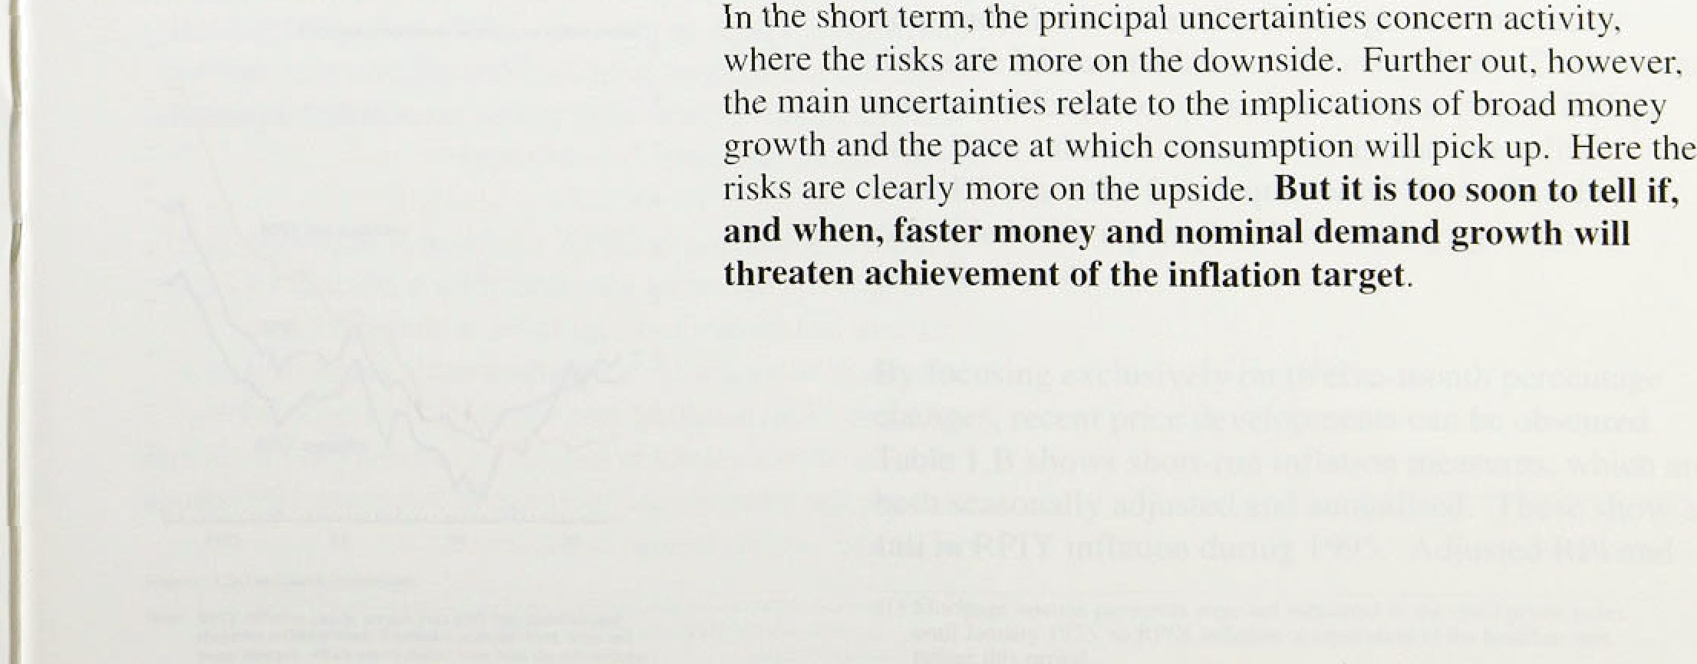



**Chart 1.1**

t¥tfl8tion !°!

### 1Rae es eas

”“ " " “ “ - • Underlying inflation has been stable since the November

*Report.* The Government’s target measure—the

twelve-month change in retail prices excluding mortgage interest payments (RPIX)—was 3.0% in December,

•• down from 3.1 to in September. **RPIY** inflation, which in , excludes the effect of indirect tax changes as well,

dropped from 2.6&o to 2.59 over the same period. The headline rate fell sharply in October, following a cut In

”" mortgage rates (see Chart 1.1).







**Table 1:A**

**headline.inflation in.tIte. G7‹•›**

Annualised,pcrcentage-changes ovCr tbc:penDd shuwa





Dec.. *I995i.*



D c j9P4







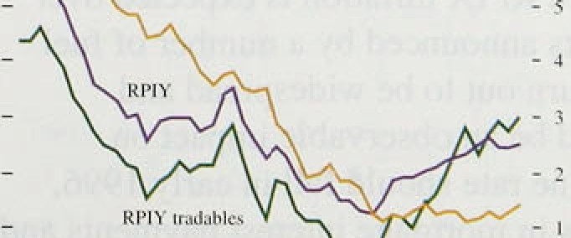

Since the current framework for monetary policy was

.introduced in October 1992, RPIX .inflation has remained below 4% for the longest period in more than 50 years. This achievement needs to be seen in the perspective of a global trend in which inflation has recently been reduced in all the major economies

(see Table 1.A). While the improvement in the

United Kingdom has been particularly marked, the rate of inflation has nevertheless remained above that in France, Germany, Japan, Canada and the United States.

###### Goods and services can be separated into two broad

.categories—those which .are commonly traded internationally, and those which are not. Exchange rate movements will affect the price of tradable goods directly. The price of tradables rose last year. following sierling s s depreciation over the first quarter. The cost of non-tradables is determined, to a greater extent, by

.domestic labour market conditions. Chart 1.2 .shows that non-tradables prices (based on components of RPIY) have been subdued, rising at an annual rate a little

over ldc since the fourth quarter of 1994. This has co'ineided with a period of.low earnings growth 1(see Section 4).

,By focusing exclusively on twelve-month percentage changes, recent: price developments can be obscured. Table .1:B shows: short-rim inflation measures, which are

%th seasonally adj,usied and annua:iised. These shoW a fnl iñ RPlY inflation during t99 : Adju.sted:RPI and,



RPIX indices accelerated in December, but this reflected duty changes in the November Budget.

The Bank has constructed housing-adjusted retail price indices which include a measure of owner-occupied housing costs (HARP is derived from **RPIX,** and THARP from RPIY). These are shown in Chart 1.3. House prices rose slightly in the second half of 1995, but fell over the year as a whole. So the HARP and THARP indices record that inflation was weaker dui ing 1995 than unadjtisted data Suggest. But since July the gap has narrowed between measures which include changes in housing costs and those which ignore them.

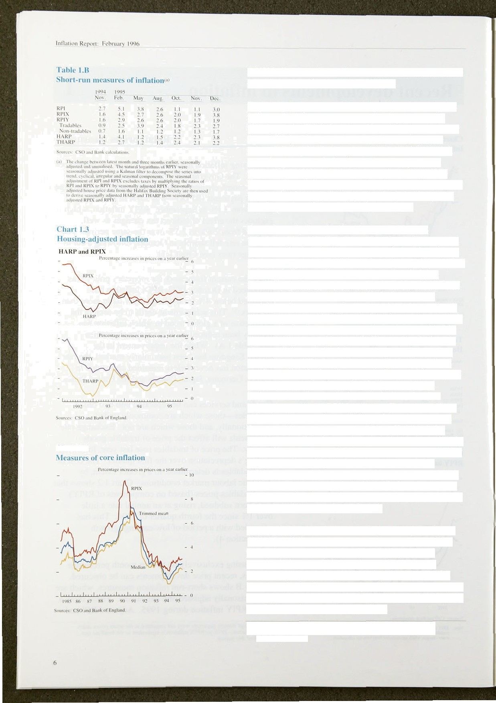

”I”H I RP and RPIY

A number of prices that feed into the RPI move infrequently and by large amounts, often reflecting cost increases that have built up over a period of time. Such chanp•es are properly included in a measure of the cost of living, yet they can distort measures of underlying inflation. So the Bank monitors two alternative indices, constructed in such a way as to liiriit the effect of outlying price movements. The monthly changes in all the components of RPIX are weighted according to their importance in the expenditure of a ‘typical household’. They are then ranked by size. ) The median is the rate above which one half of the resulting distribution lies, while the trimmed mean removes only the largest and smallest 15% of price changes. As Chart 1.4 shows, the implied twelve-month increase in these restricted indices—sometimes called core inflation—is often below the published RPIX measure. The reason is that price changes over time exhibit positive skewness-a few large price rises are, on balance, offset by mAny smaller ones. But changes in core inflation can still help to monitor the timing of shifts in underlying inflationary pressures. According to these core measures. the

build-up to a peak in the early 1990s was more gradual,

while the subsequent period of disinflation was shorter. The recent slowdown, after prices accelerated during the early part of last year, is confirmed.

A modest reductlon in **RPIX** inflation is expected over 1996 Q1. If discounts announced by a number of fuel retailers in January turn out to be widespread and sustained, there could be an observable impact on inflation. The headline rate should fall in early 1996, because of reductions in mortgage interest payments and because the interest rate increase in February 1995 drops out of the twelve-month comparison.

( l ) This meihod improves oa the appmach used in *Inflation Reyartx* up to August I99'i, which compared twelve-monih rather iJjBn monthly percentage chan#es.





Changes in expendltu e defiators (market prices)

' ntage:ciian.qcs.on!a yarenrlicr.







Seasonaliy adjusted.querIcr1y parcenlagc changes

Q2 'on:Q I ,0.B I.6: 0.8 . t.0. 1.2 2.2 0.0





1.2 Ex enditure deflators

.in principle, the GDP deflator and its components (see Table l.C) capture the price of domestic value added and so provide a more comprehensive view of economy-wide inflation than do RPI-based measures.

But tliey are both less timely than retail price measures, and subject to substantial revision up to 18 months after initial publication. For example, at the time of the

.previous *Report,* the GDP deflator was estimated to have

.risen just 1.0% in the year to 1995 Q2. This figure has since been revised to show an increase of 2.0&o. Import and export deflators both rose sharply after sterling’s depreciation in 1995 Q1, consistent with the price of traded goods being set on world markets over which UK producers have little influence. The consumers’ expenditure deflator rose by 0.49a in Q3, the smallest increase for more than five years. All components of domestic demand were subject to lower inflation than in the previous quarter. And the GDP deflator was extremely subdued, rising by just 0.1 to in Q3.



Retail price inflation stabilised in the fourth quarter of last year. Non-tradables prices rose at an annualized rate close to I % over most of the second half of 1995, adding to the evidence that domestically generated inflation has remained low.



.2 





###### Monetary growth, partiGularl.y *an* the broad!measure,

1 rru›nlh 3 iM›n,ths thy b ntunlhs ihj 12 remains high. Annual growth rates of both M0 and: M4

fi i›ics :I nd col n tJcl. t).S fi.S b. ] ¿.t,



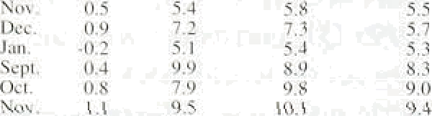

7,7 8.3



are outside their respective monitoring ranges. This section reviews the possible implications for nominal spending rind future inflation.

*N‹irro*vv *in‹›ne›’*

In the twelve months to January, notes and coin in

'',’ ', y‘, § gag circulation grew by 5.7&•, a rate comparable ivith those

! „„„,„ „ u:„q„ „„„,y in the second half of 1995, but a little lower than earli.er

„ ,• „ in that year. As shown in Table 2.A, shorter-run



7.9 7.4 fl.1 measures suggest some further modest deceleration. The

three-month annualised rate was .5. l to in January, compared with 5.5% in October.

In the past, narrow money—in particular, notes and coin—was a good statistical leading indicator of inflation. But the relationship has not been particularly close over the past two years. An:d during 1994 and 1995, narrow money growth, at,an annual rate of 69r—7%, exceeded the growth rate of nominal income by

„„ , around one percentage point. .In other words, narrow

"' money velocity—the number of times the stock of cash

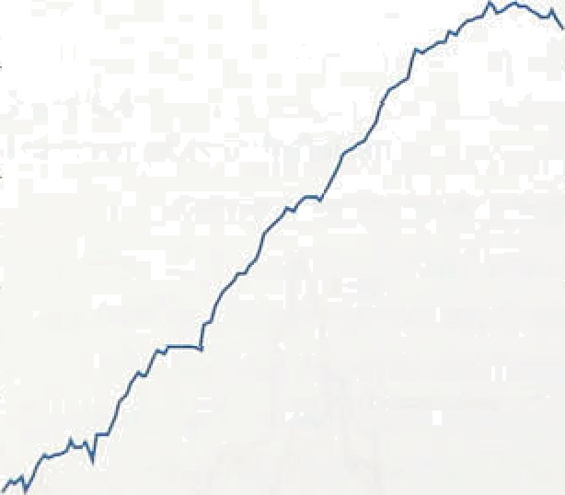is used in a given period—has fallen over the past two

^ years, after a period of stead!y growth 1(see Chart 2‘.l). The significance of the current.behaviour of.narrow money for .future imitation depends on whether:the recent. shock to velocity persists—an issuelanalysed in .the

„ February 1996 *Quarterly Bulletin.* O.ther countries:’ experience shows that periods of.flat or falling:velocity

, can persist for several years. At present, the growth in M0 is unlikely to be signalling higher inflation.

I07u 75 gf) 4fi

*Broad m.otiey*

##### ! " “ '"''* ' “ Broad money accelerated..!in.the..fourth q,uarter of 1995, when it.i.ncreased.by 2.7&o, compared with 2.4% i.n Q3. As.a.result, the.twelve-month,rate of!increase of M4:rose to 9.9% in December, fts,highest.rate since.,February 1991,añd above the,upp’er limit:of4ts monitoring range

.of 3 -9%. Sliorfer-ru!n growth.rates also increased

significantly: fn **the** three **iiiooths** to **December, M4**

8



Table 2.B

**Changes** in baiik **and building society lending‹•**

c billions

. Persons. 



busiñesses

1994' 20.9 4,3 -0.2 -J

G'.I 4.4 17.3



grew at an annualised rate of 11.49r, up from 9.9&c in September.

The significance of strong broad .money growth depends on its -causes. It is helpful to distinguish between changes in the demand for and supply of broad money. On the demand side, broad money is held as both a store of wealth and a medium of exchange. The amount people wish to hold will depend not only on the level of desired spending but also on the rate of interest paid on

Q3 3.9 1,5: 0.3

2.I 3.0 II.0

3.3 3.9 12.8.

deposits relative to other assets, agents’ wealth, and

Q4 4.0. I.8 0.4 *i-g 

ContnAutiaris to ouuuat g-th ‹a b6nk wd builaling society”Ionaiog (p‹ vantage poinrij ‹u›

|  |  |  |  |  |
| --- | --- | --- | --- | --- |
|  | Persons | ICCs | OFTS | Tdtal |
| l’994 Q4. |  | -0.j | 14 | 4.9' |
| 1995 .Q1 | 3.9 | 0.+ | 2. I | 6.8 |
| Q2 | 3.6. | I.3 | 2.3 | 7.7 |
| 'Q3. | 3,7 | '2.0 | 2.6 | 8.3 |
| Q4 | 3.6. | 2.6 | I:b | II.b |

tel' lows may nor auni iO loiols because of rouniling.



**Ckart.M**

Groas **aud.aet leading** fbr **houce** purcIzase‹•›

i lions fbJlonS .

other factors. An increase in the demand for broad money need not imply increased future nominal expenditure.

On the supply side, broad money is created by the banking system. Banks and building societies typically increase their assets by making loans to their customers. Since the liability side of their balance sheets—which is dominated by sterling-deposit liabilities—must also expand, broad money is likely to be created by the extension of credit. Shocks to the supply of money reflect either changes in the demand for credit or the willingness of banks and building societies to supply credit. A positive shock to the supply of money will increase nominal demand. and eventually the price level.

Empirical evidence suggests that the determinants of the demand for both money and credit vary from sector to sector, so it is helpful to review the sectoral breakdown of M4 and bank and building society lending.

*Credit demand*

Bank and building society lending to the private sector continued to grow strongly in the final months of last

year. Taking the fourth quarter as a whole, lending grew

.50*

by 2.2%, up from 2.0% in Q3 and 1.7&a in Q2. In the twelve riionths to December, it grew by 8.8%, compared with 8.39c in September. Table 2.B shows the Contributions to.the flow of bank and building society lending by sector during 1995.

In tbe:,fourth quarter, lending to the personal sgctor picked up. a li.ttle from the:weak outtum in :Q3: Lending for house purchase remained subdued, having weakened since the fiegirin:ing of 1995. Furtherrñore, it has increased significantly ipoye min gross than ip.*ct terms.: si*oe the summat,.flS.Chart2.2lahowsi indicating that a growing share of new mortgages has probably been used

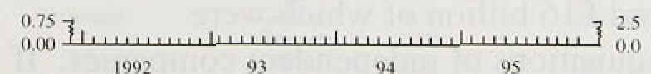

##### :ifi reg;iane.existi.rig mongages. Ending for

’

llillillion kepciri: l-cf›ru:trv l ')0fi

C’harl 2.3

**ti rowth iii li:ink** and building **s‹u:iety**

lwirrnu **ing** and **ni›iuinal iiis’cstmenl**







- 0

- I NJ

consumption strengthened further in the fourth quarter. lt rose by £1,B billion in Q4, .the largest quarterly increase since 1985 Q2. Total .consumer credit, which

includes lending for consumption by specialist lenders as. well as banks and building societies. also grew more strongly; in the three months to December, it increased

at an annualised rate of 14.99c, compared with 13.3% in September and 11.7% in June. Consumer credit consists largely of credit-card borrowing and personal loans, and it is likely to be related to spending on durable goods.

Nominal consumer expenditure on dnrables.has been robust; it grew by around ñ.0&c in the year to Q3.

However, total lending to the personal sector did not grow particu1!arly fasl last year, because. of the brake. provided by low turnover in the housing market.

Most of the increase in bank and but.lding society lending .in 1995 was to the corporate sector—both industrial and commercial companies (ICCs) and other financial institutions (OFIs). In the fourth quarter, ICCs’ borrowing increased by £5.8 billion. higher than the average .increase of £3.8 billion in the previous three quarters. The stock of lending to ICCs stood at

£142 billion in Q4, 13.69r higher than a year earlier.

OFIs’ borrowing was strong too; .it increased by

fi14-7 billion over 1995. The stock of lending to OFIS stood at I 127.1 billion in Q4, 13.59r higher .than a year earlier.

Chart ?•.I

:Scquisilions **and mergers in** the **corporate**

sector







10

Taken together, borrowing by ICCs and OFIs accounted foT .almost all of the acceleration in bank and bu!i1ding society lending in 1995. .Part of the. increased borrowing may be related to investment in fixed capital. Nominal investment expenditure by ICCs, though erratic from quarter to quarter, increased in 1995; .in Q3 it was 7.6& higher than a year earlier. Chart 2.3 sliows'that in’ the past the growth in ICCs’ borrowing from banks and building societies has.moved quite closely witli investment expenditure..

Corporate take-over activity'incrñasefi significantly in 1995,. and could explmn a 1arge ,proportion .of the increased borrow.i.rig by both ICCs!and OfiIs:(see Chart 2.4). In tfie:third quarter, mergers and acquisitions



##### In the first three quarteri1.of 199ñ, théy amountyd to

.£23 billion, around fiI6 billion of"whfch’were

.cash-financed.acquisitions:of independent..companies. If all tliis had been financed by borrowi.rig from batiks.and building societies, it:would.have,accounted$or around

##### .two tbirds of the increase in bank and buildtngsociety



Chart 2J

Share and {tilt prices,



Tm*sug20Cs

- 120.0

- I I 5:0

lending to ICCs and OFIs, although it includes Glaxo’s take-over of Wellcome, the debt finance for which was repaid in Q2 and Q3. Acquisitions and mergers in the United Kingdom by overseas companies also increased in 1995; in the first three q uarters they were

£7.0 billion, almost £2.0 billion greater than in the whole of 1994. Some overseas firms may also have set up UK companies for the purposes of acquisition, which might have led to additional lending to the UK private

sector. If firms pay back *bank* borrowing once current merger and acquisition activity subsides, the supply of M4 to the corporate sector will fall back.

Chart 2.6

1.995 9r›.

The significance of increased take-over activity depends on its causes. Equity prices rose sharply in 1995, and this may have reflected higher profit expectations or lower perceived risks. To some extent, it will also have reflected lower real interest rates, bul this cannot be a complete explanation as equity prices rose by more than

inñex-linked gilt prices (see Chart 2.5). As Chart 2.6

FT-SE price indices

- - 130

shows, the rise in the market was especially marked in a few categories of stocks where take-over activity had bin most prominent, in particular, electricity distribution, financial services and pharmaceuticals.

These developments led to a rise in private-sector wealth, which is likely to cause both consumer spending and investment to increase. That possibility is discussed in Section 3.

Rnmced:priñcipally by



n»





FT-8E.All 8harr (a)

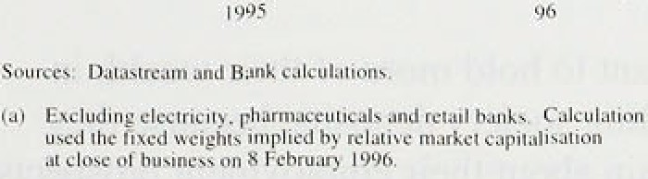





The government, too, borrowed significantly from the banking system in 1995. The profile of the PSBR over the financial year to December was similar to the profile to December 1994, but the pattern of financing was different. A larger proportion was financed by borrowing from the banking sector (including building societies), particularly by means of Treasury bill sales (see Table 2.C). This led to an increase in the assets of the banking sector. enabling it to expand its liabilities and thus .M4. It is expected that net gilt sales in the first quarter of 1996 will reduce the outstanding stock of Treasury bills. Tliat would, at the same time, reduce the public sector’s stock of.borrowing from the banking sector and help to bring down the growth of M4, unless

in the banks’ demand for gilts following the introduction in.January of the new open g repoo..::mar ket.

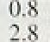

:2:6.





The deposits of OFIs (acéounting for about

 



ii fi.tth. of .M4) grew most rapidly—at am annual rate of nearl.y 2ñ% in 1995 Q4. Deposits of persons, which represent ai’ound two thirds of the. stock of .M4, grew by abotit 79c. l.CCs’ deposits t about l I'm of M4) were subdued in the first three. quarters of’ 1995, but rose sharp.ly in Q4 to gi.ve an annual growth rate of nearly

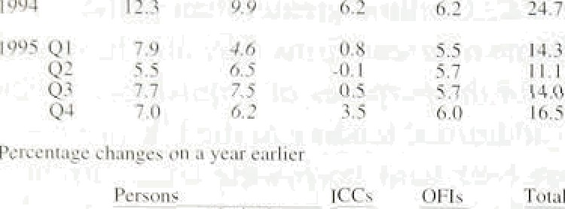

Individuals’ holdings of M4 have continued to increase since the November *Re not t,* although they are no longer accelei-ating. They rose by £6.2 billion in Q4, compared with fi7.5 billion in Q3 and Cñ.5 billion in Q2. .Both bank and building societies’ inflows slowed in the fourth quarter. To some extent this:.reflects fal.1s in the rate of interest paid on deposits at the end of 1995; between September and December, average bank and building society 90-day savi.ng account rates fell by 32 basis points and 45 basis points respectively (see Chart 2.7).



The relati ve attractiveness of other financial assets may have increased. Retail inflows into un.i.t trusts were around £900 ini.11.ion in Q4. compared with f740 million

* 1. Q3. For the fourth quai’ter as a whole, in.flo.ws to national savings Increased to I 1.2.bil.l.ion, up from

20.8 bill.ion in Q3. But these effects were small relative to the change in inflows to banks and building societies.

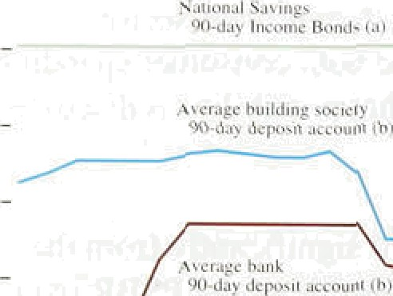

The build-tip in individuals’ deposits in 1955 might be part of an adjustment to a hi.gher level of long-run des.ired money holdings for a given level of nominal expenditure—a shift in..money demand. Tw.o factors

, , might have led to.such a sh.i.ft.

(i) People may want to hold more of.their. wealth in bank and building society deposits, because they remain uncertain about their employment pro’spects

 and the outlook for the housing marke1t-=-a shift in. the willingness to hold deposits arising from:,an increase ifi precautionfiry saving. Bu! w.ith .the personal sector say.ing ratio...i.n. 1.595 Q3. below its level at .the end of 1994, and with unerfiployrhent conti.nut.rig.to..fa:11, th!is i.ncrease in precautionary savi.ng .is. unl.ikely to.!account’ for all’of the rise ix in‹dviduals’ :deposits during .1995. And the: ’acceleration of’constimer iéredit ifi recent months suggests that lire .prec3utionary motive did not: apply t'o everyone.

(il) .S:ome investors have increased their hold Ings,in building society accounts so as to qualify for bonus payments in the event of future!take-overs.

Individuals' building society deposits rose by



£3.2 billion in Q4, lower than the fi3.8 billion increase in Q3, but broadly similar to rises in Ql and Q2. Some societies have tightened the criteria for qualifying for bonuses. which may explain some of the slowdown in Q4. But banks also saw an increased demand for deposits during 1995, without the prospective bonus incentive.

So the argument that personal sector deposits have simply been adjusting towards higher equilibrium balances is not wholly convincing. But the slowdown in the growth of individuals’ deposits in Q4 offers some reassurance that planned spending is not

accelerating.

OFIs’ deposits with bank and building societies increased further in the fourth quarter. They rose by

£6.0 billion in Q4, compared with increases of

£5.7 billion in each of Q2 and Q3. Since OFIs are the main marginal source of funds for the banking system in the short term, it seems likely that banks and building societies have bid for these deposits in wholesale markets to fund their increased lending. And OFIs will have had additional funds available. having sold shares in companies which were taken over for cash. The rates paid on wholesale transactions are not typically recorded for statistical purposes, but data collected by the Bank on representative interest rates paid on OFIs’ deposits suggest some increase relative to market rates in the second and third quarters. The change is small, but because wholesale deposits are very close substitutes for other money market instruments, small changes in the relative interest rate are likely to have large effects on the demand for M4 by OFIs.

After modest increases in the first three quarters of 1995, ICCs' M4 deposits rose sharply by £3.5 billion in the fourih quarter The largest comparable quarterly increase in deposits occurred in 1994 Q1, but then deposits of utility companies were inflated by the prepayment of fuel bills ahead of changes to VAT. Part of the strength in Q4 could have been related to take-over activity, with some firms building up liquidity before making a bid.

Other firms that sold shares in companies are likely to hold higher deposits until they have reallocated their portfolios. Increases in ICCs’ deposits have in the past been associated with higher planned investment; firms

may:often set aside deposits well in advance of ’lumpy’ investment expenditure. )

{I).Spec Haldane, A G.and Actltj, M 8 (1995), ‘Money as in indicator’, foul

***’oj England WorI‹in$ Paper to 35,* July.**

lnfJ• Ii‹›n Reourl: Fohruo I0'?6

Bringing the evidence together, it appears that the demand for money may have shifted .relative to desired spending. But it is doubtful that this can explain more than part of the continued strong growth in M4 in the second half of last year. Stronger M4 growth reflects, therefore, an increase in the supply of money, resulting from the increased credit extended by the banking sector. In turn, this seems most likely to be related to increased cash-financed mergers and .acquisitions activity arid stronger equity prices. As and when mergers and acquisitions activity subsides, the supply of broad money may fall back, as firms readjust their balance sheets by issuing new equity, using the proceeds to repay the debt relatively quickly. .If, .in such circumstances, broad money were not to decline, that would be a cause for concern.

In conclusion, it is likely that M4 is signalling higher planned spending in the future, although it is too soon to tell whether recent growth rates of broad money will persist.

*Divisiu mviie y*

The Bank has constructed a monetary aggregate- Divisia money—which is related as closely as possible to the use of money in transactions. The Divisia measure of money attempts to allow for the varying transactions properties of the different monetary assets within M4 by weighting them.according to their 'user cost’—the difference between.the rate of interest the component asset offers and the return on a benchmark asset that is assumed to offer no transactions services. If these weights reflect differences in the transactions services provided by the various monetary assets, then the resulting Divisia index will provide a better measure than other aggregates of the total quantity of money held for transactions purposes.

The Bank’s Divisia measure accelerated through 1995. It rose by 7.9% in the year to Q4, up from fi.3&o in .Q3 and 5.3&» in Q2. This compares. with.!annual growth.of less than 5&• during most of lSS3:and 1994. Personal sector DiNisia continues to grow quite strongly, although it is: rio longer.accelerating.. In .199a !Q4, .it rose.by 1,4d

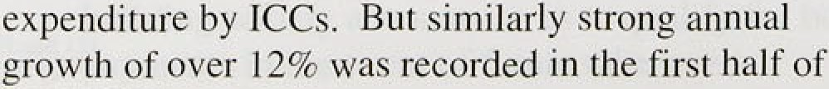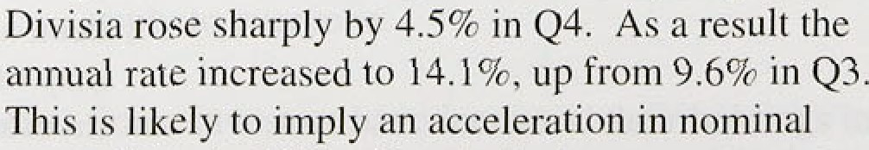





**.Changes in official and** key interest’ rates‹•!‹°›

In'.ph'reniilogiea1 border; per cent per annum

to.Mfiy: f olcre4f' rgR. Date.. CbAnge; Gauge



Jnun'enfion'mie 16 Nov. -20 4.80

1994 and ICCs’ capital expen:diture grew by only 4'/4&O in .that year as a whole.

22.22 **Interest** rates and exchan e rates

firance' Uni(e'¿.Kidgdom.



Canadn United'Ki Ogdens

Getzri fry Uniied States





Gcnnafiy





Chart 2.8

lnñrvewiiQ mte ’7Dec.- -t0. 4.70



F«lcMfundsae’ l9’D‹c: ’-25 :5V

 20.Doc: -1 6 . 6.06'

.] y’’épO.’.MM 

1. IO d4y 'repo rkte: 2 I 'Dec,. -IS 5.85



Bank rcte 31 Jan. -37 3.3’7



ficdenil funds. mie' 3 I Jan. -2f 3.25



Intervention rate I*Fcb. -J 1' 4.05'

 -1:0’ 3:30

lnie nugn:nks’ 8Fgb. 

Since the November *Report,* official UK interest rates have been reduced in two successive 25 basis-point steps and now stand at 6.259o. Other countries have also cut their Official rates; in particular the US authorities cut the federal funds rate by 50 basis points to 5.259a and in Germany the Lombard and Discount rates were reduced by 50 basis points to 5.0% and 3.0% respectively (see Table 2.E). The Germa n repo rate has also been reduced in successive steps and stood at 3.30% on 9 February compared with 4.029s on 3 November.

UK short-term market interest rates have generally fallen by as much as official rates. On 9 February,

three-month Libor was 6.259a, compared with 6.75% on 3 November. Chart 2.8 shows some of the interest rates

paid by different borrowers or used as a basis for

**Interest rates**







.Cbart 2:9



**Sterhag izzterest.rate ezpectatioos‹•›**



###### calculating their borrowing costs.

Following the first reduction in UK short-term official interest rates in December, mortgage lenders reduced rates by a further 25 basis points. This was the third move in recent months; most lenders had cut their variable rates by around 35 basis points in September and by between 20 and 40 basis points in December. Most of these cuts will be effective by the beginning of February, bringing the average bank and building society variable mortgage rate down to around 7'f•%, the lowest rate since .1966.

Futures markets have revised down their expectation .of UK short-term interest rates since the November *Report.*

The current.structure of short-sterling futures prices

* suggests that markets expect interest rates to fall further during the next six .months before picking up a
* little .thereafter. The rate on LiFFE s June 1596 contract fell from 6.519b on 3 November to 5.82% on

**9 February. By December** 1996, interest rates are expected to be around 6&o.

.Az Chart 2.9 sho.we, short-term interest rate

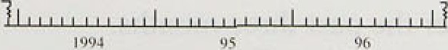

##### .expectations in the United.Kingdom have.been falling since.Je end of 1994.; at the time of the Noxember 1994



###### : tions in 1994 and early 19.95 :niay:pri›vide:aii



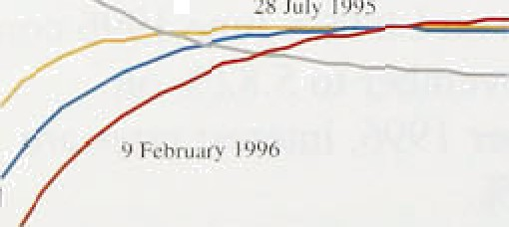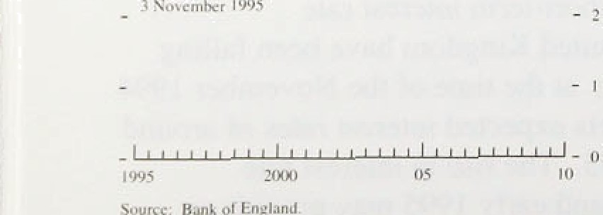

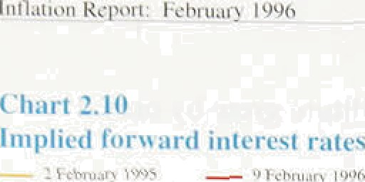explanation ofi the slowdown in deinaii‹dand output through 1995. Monetary policy was more restrictive than iiioveincnts in official rates suggeste‹L



° Yields have also fallen on longer-maturity bonds since the November be/ar›rf: UK ten-year recleinption yields fell by 30 basis points between 3 November and



9 Febi’uary. But as Chart 2.10 shows, the implied forward interest rate cui’ves for the United States. United

" K ingdom, and Germany have niovecl differently since the November *Re not t.* In the United States, implied f’orward rates fell at both the short and .Jong end .of the eiirve. In the United Kingdom a.nd Germany, all of the movement occurred at shorter horizons; expected yields a1 longer hoi’izons rose.

i›

Over l .995 as a whole, the 13.4 basis-point decl.ine in UK

ten-year bond yields was the smallest i.n the. G7 (see

* + 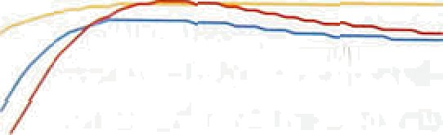Table 2..F). In Germany, France, Japan and the..United States, implied torward i’ates fell at all m‹iturities. UK implied forward rates, on the other hand, fell at shorter maturities, but inci eiised at maturities beyond. twelve

,. year’s. This suggests that, as the United K.ingdoin and the other major economies have entered a period of slower-than-expected growth, short-ter rn interest rates have been ctit, but the premium to hold longer-term UK government debt has increased:

Movements in UK bonar yields can ñe decompose4 into changes in expected real. interest rates and changes i.n



.expected inflation, although the calculation can be affected by i isk premia. During l99J, UK expected real interest rates fell: In a world of highly integrated capital markets, the long-term real interest rate is.li.kely to be similar across .countries. Bank.research (or the G10 Deputies’ study on saying and investment, reported in the February 1996 *Qucirterly Bulletin;* suggests that the. degree of intégration has. increa.sed since the early

.1980s, making convergence of rgal rates more1.likely.. Hence differences in lpng-terrñ bond..yields.are li:kel:y to reflect inflation expectations in the long ruri—.a

function of the credibility of lo'ng-term riion‹itary policy—and expected changes ion real exchange .rdtes; whlch i.n most cases. ate un1:ikely to be sig.ni!ficarit.over long. periods,

Tlierâ has been an improvement ln-mdasured UK inflation.ehpectations over the.past three months. Inflation was expected to be 4.2%.in five years' time .on

:9.Febniary compared with 4.5,8• .on 3 November. B.ut,



**Chart ?.J2**

Sterling exchange retes



2.'J0. -



as Chart 2.11 sliows, inflation expectations at horizoll s beyond ten years are now generally higher than at the beginning of last year.

*“*’- .* On 9 Febmary, sterling’s effective index was 84.1,

* 1. virtually unchanged from the time of the November

- i.‹i *Report.* Within this period, stefling fell to a low of 82.2

- .a on 20 November, before strengthening during December

i. and at the beginning of February.





 

- TmJc-weighed index

- 1.52

' - '90

— 87

- g6

In the past, sterling and the dollar have often moved together. suggesting that they typically respond to common factors. In the three months since the November *Report,* the dollar’s effective index has appreciated by nearly 39r. In spite of this,

sterling’s effective index has remained almost

unchanged.



Cbart 2.13

UK effective exchange rate profi4es‹•›



'/ Eiw-year' X Ten-year





› Chart 2.13 shows the expected ten-year path for the

,‹ exchange rate implied by interest rate differentials on

,› 9 February and at the time of the previous two

, /n/arion *Reports.* It shows that. compared with three

* months ago. the future level of sterling is now expected to be lower. The rate of depreciation is also expected to be slightly faster—the latest figures suggest sterling is expected to fall by around .10Tr over a ten-year period. compared with a fall of 9% at the time of the November *Report.*

2.3 Summar

There are some signs of a modest slowdown in narrow

.money growth. Broad money continues to grow rapidly; in December, annual M4 growth was 9.9%, above the ceiling of its monitoring range. The demancl for money may have risen relative to desired spending, but this is unlikely to explain the continued strength of M4 in the second half of last year. Instead, this seems to have reflected an increase in the supply of money, related to increased bank and building society lending to the private sector for take-over purposes. This would have few direct implications for future nominal .spending if tire higher money supply were only temporary, but that is far from .certain.



##### Official interest rates have been reduced in the United

Kingdom and overseas since the November *Report.* Futures markets expect UK short-term rates to fall further.over the next’six months. Yields!at longer ñiaturities.have.also fallen in the United Kingdom,

##### ,though, in contrast to some other countries, by much less



than rates at shorter maturities. This could be related to an increase in UK inflation expectations in the longer term.

# Demand and supply

**t’harl .3. I'.**

I K uriil ss i›rli1 ‹leiuu nd gri›,u Hi

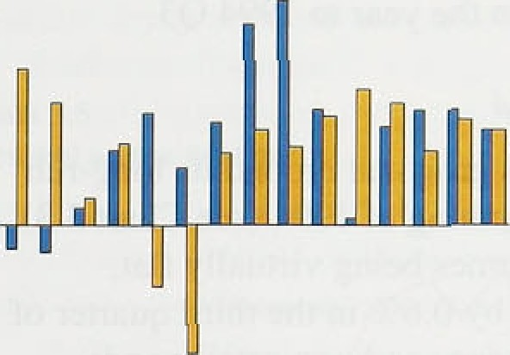









0.0.'

* 1. Oi’eri’ieiv

Domestic demand, excluding stockbuilding. increased by 0.2°Zr in 199a Q3, after i isinp by (l.7“/c in Q2 and



' 0.4% i.n Q1. Stich volatility is evident in all components of GDP, so it is useful to look at a moving average ot’ growth rates. Chart 3.1, which uses a two-quarter moving averap•e, shows there has been iiitle sign of any underly in.g change i.n the quarter1.y growth rate of domestic demand excludin* stockbuildiny over the past

, , year. .Data .foi domestic demand in 1995 Q4 will be released with the second estiin‹ite of fourth-quarter GDP, which will include a prclirninai y esti.mate or its composition.

Domestic dc•inand, excluding stoc kbui.lding, in the major si.x overseas industrialised economies' ' '—which account for around one Uh r of UK exports—increased by 0.37c in 1995 Q3, after disinj by 0.7Vc in Q2. It was up L7Vr over the year to Q3.



**UK GDP** gro.wth has slowed steadily since the middle of’ 19194. It was 0.4'T• in the fourth quai‘ier of 1995-less than most estimates of its long-run trend irate

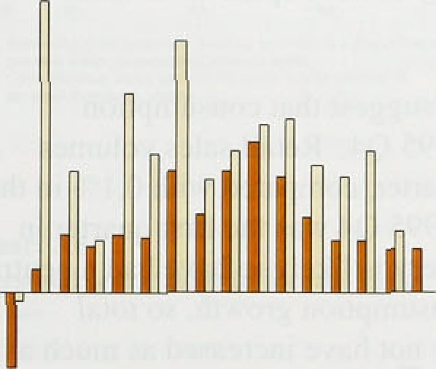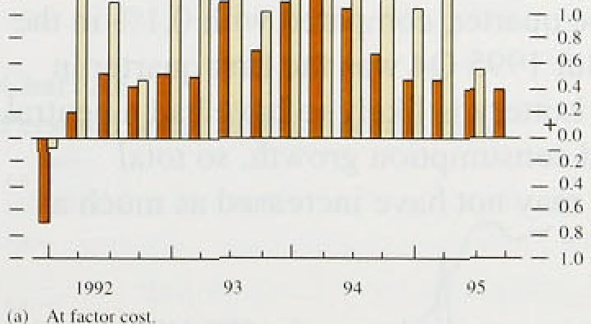

- ?.2'

(see Chart 3.2). The estimated i’ate of GDP gi’owth in the.third quai ter was i’evised down slightly from O.S'7r to 0.47c. Non.-oil GDP is currently estimated to have increased by 0.49r in 1995 Q4, after gi’owinp• by 0.3+r in the. thi.rd quarter.

Nciminal GDP has also decelerated. It increased by 0.6Uc in the third. quarter—the most recent quarter for whiéh data nre available—compared with l.37r in the second. The an.nual growth rate fell to 4,17r: But. as a re’su:lt of a sharp upward revision in the estimated GDP deflator in the second quarter, nominal GDP is now estimated to have expanded by 5.2' r in the year to 1995 Q2.. This .compares w.ith. the 3.87r estimated at the time of the .Noverriber *fie/›o!rt.*



. 3.3 **Domestic demand**

Doinestic demand .increased .by 0:57r. in the third quarter of 1595: Table 3.A:sliows.how the various expenditurel



thart J.1

£rr‹›n’th iit c‹›nsunjer spending

- 0.8

###### components of GDP contributed to *changes* in the growth of output during the recovery. It is possible:to examine which components were responsiblelfor the recent slowdown in output growth, as well as those which caused the initial move from recession to recovery. GDP was 2,1 to higher in 1995 Q3 than it was in 1994 Q3, but 4.1% higher in the latter period than.in 1993 Q3, so the four-quarter grow,th rate fell by

two percentage points. Net trade accounted for almost. the entire slowdown in GDP growth in the four quarters to 1995 Q3. The table also shows that the combination of stronger net trade and stockbuilding accounted for the acceleration of output in the year to 1994 Q3.

*Perform .sector denicind*

Consumer spending has grown at around its long-run. trend rate since the beginning of 1994 (see Chart 3.3). Despite retail sales volumes being virtually .flat, consumption.increased by 0.6&o in the third quarter of 1995. Spending on services and non-retail goods accounted for the entire increase in consumption. Part of the explanation for robust consuinption growth in recent

- - 0.6



- — 0.6

Chart ñ.4

Consumption as a percentage of GDR*›

###### quarters was the National. Lottery, half of the gross spending on which is included in consumption—that is, spending after prizes are paid out. So far, the Lottery has had a deflationary effect on the economy: the recipients of Lottery funding have yet to receive much and prizewinners are unlikely to have spent all of their winnin8S.

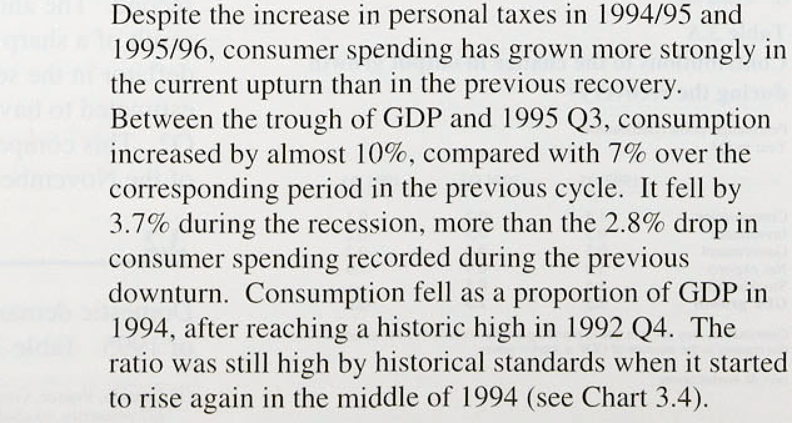Preliminary indications suggest that consumption increased robustly in 1995 Q4. Retail sales volumes were up 0.8*la* ion the quarter, c:ompared with 0.1&o in the previous quarter. But *1995* Q4 was .the first quarter in which the National Lottery is likely to„have had a, neutral impact on measured consumption growth, so total consumer spending may not.have increased as much as retail sales.





**'Ieble.3.B**

**Housing market.acti'vity**







Tumov.or tel ..&.0. -10:7' - l:6 -0: I -5.1

Price rbi 0.6 - .6 U. I - I .3 - I .0



-a.s

-2:9

07



.Consumption tends to grow at around its long-run trend

.rate unless there is unexpected news about consumers’ future ,incomes, there are unusually high or low real interest rates, or some groups of consumers are

.attempting to increase their wealth relative to their income. One of the uncertainties for con.sumption is whether the willingness of some consumers to borrow more will be affected by a desire to build up precautionary savings.

Chart 3.5

**Personal sectur gearing**

The number of consumers willing to borrow more will be affected by the amount of debt held in relation to total net personal wealth—that is. capital gearing. If capital gearing remains high, some consumers may wish to pay back debt, so they are better able to accommodate temporary changes to their real incomes without

###### *•••• ,„ changing their consumption.

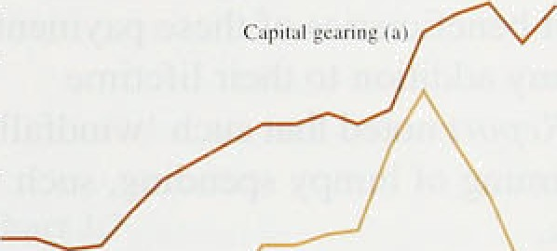



Chnrt 3.6

**Personal sector debt to income ratio**

Raio

4.O-

3:0:—





Housing accounts for just under half of total net wealth of the personal sector and individual holdings of shares and other securities around 10%, with the remainder consisting largely of claims on life assurance and pension funds, and bank and building society deposits. According to the Halifax house price index. house prices fell by 2.7% between February and July, before rising by l.2&o during the remainder of 1995. The Bank’s estimates show that the number of people affected by negative equity rose from 0.9 million to 1.1 million in the second half of 1995, while the total value of negative equity increased from £4.2 billion to £4.8 billion

(see pages 26W7 of the August 1995 *Quarterl )• Bulletin ).* Table 3.B summarises developments in the housing market.



Other groups of consumers, however, may increase their

R'- «i spending because the rise in equity prices has increased

_ „„ their overall wealth. Chart 3.5 shows that. in aggregate, capital gearing was higher in 1994 than in 1993, but it

' '" probably fell a little in 1995 as the decline in house

— • =› prices was offset by a 20% increase in equity prices, so

_ „p lessening one constraint on spending. The ratio of the flow of borrowing to income supports that interpretation.

'°' Chart 3.6 shows .that, in the 1980s. after direct controls

- •• .on financial intermediation were withdrawn, personal

**.debt.as.**.**a**a**.**. p roPortion Of income rose sharply. Although

the dgbt-income ratio fell slightly during the recession, it

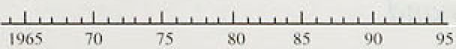

' resumed its upward climb in 1993. This suggests that many indiviiiuals’ incomes had risen far enough to bring tiietr dibt-income ratios down to desired levels, and so they were prppared to take on new debt.

lntliitiou Repori: 1•ebruary l99t›

The cost of servicing debt depends. on both the stock.of

.debt and the. level of nominalunterest rates:. interest payments fell. sharply as a proportion ofi.disposable income after 1990 (also. shown. on Cliart -3.5),:.as the stock .of debt was..reduced slig1it!y in .relation to income and nominal interest rates fell. However, the ratio .has not yet returned to pre-1980s .levels; and:some consumers may remain cautious. about spendi.ng in the future.

"Fable 3.C

H uilding **society mergers** arid conversions



dispo ublc



The path of consumption during 1996 will depend partly on how much is spent out of .the “windfall.gaits’ from building society mergers and conversions to plc status. Table 3.C lists those mergers and acquisitions which have taken place recently or been announced for a later date. The noted,. first, that few!of these one-off payments would ificrease the net worth of the personal sector—the electricity rebates a!re a different case—and, second. most beneficiaries of these payments

› *• coi:Id have anticipated any addition to thqir.lifetime income. However. *the.Report.noted* tha:t such ‘windfall





1 901 H I

IW7 H



with T3B

Abhey f•iatiunfi take-t›yer



huildiny socic1y



Fcrritanent building society

Wrx›l\vlch huildinjz society



o

I.4

gains’ could:affect the timing.of lumpy spending; such. as that on durable go:ods.

So far, there is little evidence of how the pay-outs have affected spending patterns. B.ut the pay-outs in!the third quarter could help explain why..consumption continued to increase at its tren‹i rate, whfle real .personal

disposable incomes fell for the second quarter in a row.

c‹›nve' ion In plc status 2.°i—3.1) f):fi—0.6



A survey of 2,086 consumers, conducted.by the Harris Research Centre in October 1995 on behalf of Nlkko Europe .plc, found that, of people.wlio hail!.receive;l, or were expecting,.a 'windfall gain':from a buil‹iing society pay-out, 62 o intended to sgve most.of it, while. 369. said they would spend most, or all of the gain.

So, excluding Lottery spending, consumption is likely to accelerate from just below’to just above its long-run trend rate of growth although there is la risk lthat spentiing could increase faster!because of.the.increased liquidity from bui1din!g society mergers an‹i,conversions and the windfall-gain electricity rebate. : But both

.consumption and.personal debt!ymain.higii as a prop:ortion of GDP, so some consumers will probably

!sfill with to rebuild their balance sheets,



**’l“ablc .3.Ei**

I ii i **cstrneirt lis ussei**





Transl'c r c‹›.iiS u l' I:ind



**Tolsl** *grnss* domestic



Chart .3.7

**Stuck-market** s al uatir›n **rat** ii›

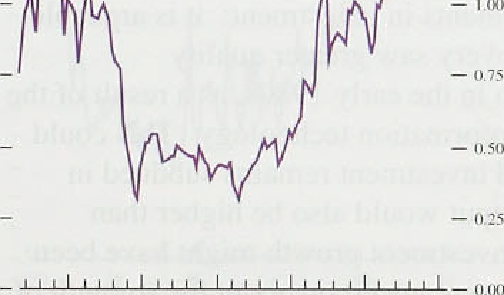

é0 SS 'JO OS



in the November be/›orf (see Table 3.D). Pl‹int and machinery investment rose more strongly. Aggregate investment growth might remuin lr›w this year if

investment in r a• t and machinery t’ails to ot’fset s)ower growth in construction investment. The l‹itest B riti sh

Chambers of Commerce ( 8CC) Survey noted a marked downward shift in the number ot’ t‘i rms planning tO in vcst in buildings—pariicrilarly in the sei vice sector. Overall, the balance of firms revising their building investment plans upwai’ds was the lowest since 1993 Q4. The number intending to invest in plant and machinery was stable—if low—in both manufacturing and ser vices. according to the **BCC.**

New investments are profitable when the market valuation of the profit stream on new capital is greater than the cost of installing it. The i atio of the market valuation of capital to the replacement cost of cap it.it is known as the valuation ratio or Tobin’s ’‹y’ .' ' A valuation ratio greater than unity means that firus haste an incentive to invest, because existing shareholders can make a profit by financing purchases of capital goods by issuing new equity. The Bank’s estimate is a calculation of the *en’ri‘ci ye* rather than the *mcirgiii‹il* valuation i’atio: the latter is. in theory. the appi’opi’iate measure. It is also affected by changes in the value of overseas assets of UK-quoted companies, and so does ntit gi ve ‹in unambiguous signal ot’ the incentive to invest in the United Kingdom. Nevertheless. the Bank’s measure has been above unity since the end of 1991 . It peaked in 1993 Q in the next quarter, investment rose by 4.37c. Excluding this period, the valuation ratio is estimated to have reached its highest level for more than 2ñ years in the third quarter of last year (see Chart 3.7). That makes the low p•rowth of investment surprising. It may reflect the sharply differing foi tunes of different industries.

One indication of the incentive to invest in dift’ererit sectors of the economy is given by diff’erential movements in share prices. Over the whole of 1995, the share prices ot’ construction companies fell sharply relative to the FT-SE All-share index. mirroring the weakness of consti’uction investment relative to total capital spending. although the relative price of construction shares started to rise towards the end of last year.

It is also difficult to reconcile the weakness of’ investment with the fact thai equity prices have risen more strongly over the past year than index-linked

(l )



February' 199f› BanL of End land hf«rfi•rfs• *Bit lletii i.*



Ins estnient as a propurtinii nl’ CiDP‹•'



i ii i Ai const *ni rnarhet prices.

gilts—the prices of which were pushed up by lower real interest rates. Section 2 noted how the buoyancy of equity prices has been associated witli greater mergers and acquisitions activity. Either investors expectations of corporate profitability have risen—in the United Kingdom or overseas r the risk of holding equities has fallen relative to holding bonds. If confidence .in .the outlook for corporate profits relative to the cost of capital had increased in the United Kingdom, investment would be expected to rise.

Why, then. has investment growth been so sluggish?

* + .. There are several possibilities, none of which is entirely convincing. First, in contrast to the previous recovery, the investment-output ratio may already have been close
    - to its long-run average, with less ground to ‘catch up’ after the recession. But Chart 3.8 shows that, even when measured as a proportion of **GDP,** investment fel.l in
    - 1995 Q3, and has been on a downward trend since the

, trough in output. The recent decline could be a temporary phenomenon, if some firms postponed their

' investment plans in response to the slowdown in output

, growth. This explanation sits oddly with strong equity ' prices and the valuation ratio being greater than unity..

Second. investment—particularly in information technology—could be underrecorded because the CSO does not include spending on software in its measure of investment. Nor might the CSO take sufficient account of quality improvements in .investment: it is arguable that the recent recovery saw greater quality improvements than in.the early .1980s. as.a result of the increasing use of information technology. This could mean that recorded investment remains subdued in 1996; potential output would also be higher than expected. Third, investment growth might have .been low because firms were .uncertain about the strength .of future demand for tiieir goo‹is. This explanation is not supponed for the manufacturing sector: the proportion of.firms .recorded by the CBI as limiting investment because of uncertainty about future demand has.ñeen

.falling since the beginning of 199a. Fourth, demand.for

.construction output:has been subdued throughout the " recovery, reflecting excess supply built up, iiuring the

boom of the l980s.

According to survey evidence,.investment intentions remain strong., Although the January CBI Survey showed that the balance.of respohdents who Claimed to inyest in.plant and machinery oVer thy following .year fell front +12%.in the third‘qiiarter to. +10N itt tlie foutth quarter, the balanceiemained **sig;jiñcantly** above **its**

**Chart 3.9**

**Investment goods!as a share of imported finished manufactures‹•i**

long-run average. Also, in 1995 Q3, the share ot capital

###### goods in the total value of finished manufactured

.imports was at its highest since 1984 Q2 (see Chart 3.9).

— " - • In the past, increases in imports of capital goods appear to have preceded pick-ups in domestic investment in plant and machinery.

Industrial and commercial companies' (ICCs) gross trading profits fell in 1995 O3, after rising in the previous quarter. Profit figures have been relatively volatile over recent quarters, however, and were still 5.8& higher in 1995 .Q3 than in the same quarter a year earlier, and dividend payments continued to rise. The ratio of dividends to post-tax income—the 'dividend

pay-out ratio’—was 20.49c in 1995 Q3, up from 19.29c £t

year earlier (see Chart 3.IG}.



**Cpart 3.10**

**Dividend payout** ratiot*›

hCs’ net borrowing rose from £5.2 billion in the second quarter to £7.4 billion in the third. This borrowing could ñe funding stockbtiilding, fixed investment, or mergers

.and acquisitions (see Section 2). The value of mergers and acquisitions by UK companies—both at home and abroad—increased sharply in the first three quarters of

* + - • „ 1995 to an average of £10.7 billion a quarter. compared
      * ‹ with a quarterly average of £5.9 billion in 1994. It was
      * '• close to the alI-time high recorded in 1989.

- 22

- 20

— 14

- I2'

-..I0.

—, — 0

1 970 7T. !% BS . 90 ’95





###### In the November Budget. public investment was

to increase slightly to £21.7 billion in 1995/96 from £20.9 billion in 1994/95. This implied that it would remain broadly constant as a proportion of money GDP. But public investment was projected to fall—both in absolute terms and as a proportion of money GDP— over the following three years. The Private Finance Initiative (PFI) contributed only £0.3 billion to investment in 1994/95, and is expected to add



£0.ti,billion in 1995/96.

Stockbuilding(1)

Stoekbuilding has boosted GDP in five out of the past six quarters. The August and November *Reports* discussed the risk that companies would run down stocks in the second half of 1995 and the first half of 1996.

There is no evi‹ienee that this occurred in the third quarter. According to the latest National Accounts, Stocks increased.by £1.4 billion in 1995 Q3, after rising ' by £1;bi1lion in Q2., Successive data revisions have

* + changed tlie .recorded profile of stockbuilding. In particular, ihe 1994 .Q4 estimate of stockbuilding has

'.(i} Al.m '.nrinnmsin 8fis aecñon are quoted an 1990 ptices.

.25

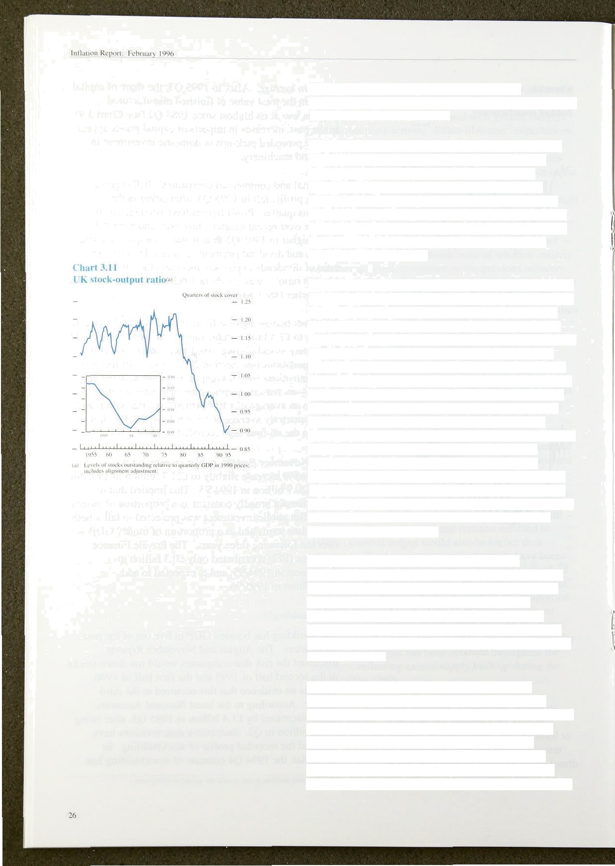been revised up from an initial fiO.8 billion to

£1.9 billion, while the figures for the first two quarters of 1995 have been revised down.

The interpretation of the stockbuilding data is clouded by the inclusion of the alignment adjustment in the stockbuilding category of the National Accounts

(see the box on page 24 of the May 1995 *Inflatiun Repnrt ).* But separate **CSO** data—which exclude any alignment adjustment—also show that stocks increased sharply in Q3. They were up £1.2 billion, following an increase of f.0.8 billion in 1995 Q2, pushing up the stock-output ratio further.

The behaviour of stocks provides an important clue as to the likely path of output over the following few quarters, because output is sensitive to changes in stock levels.

The overall stock-output ratio has been on a declining trend since the early 1980s. falling by around a quarter in that time. The downward trend has been interrupted periodically, when stocks have built up involuntarily in times of weaker-than-expected demand (see Chart 3.11).

If firms build up stocks when demand—either at home or abroad—turns out weaker than expected, they may later attempt to reduce their stock levels by cutting output. Firms may also increase stocks in anticipation of strong demand, however, or they may buy in raw materials ahead of expected price increases. The

stock-output ratio started to pick up towards the end of 1994. The path of output will depend on how much of this increase was involuntary, how quickly any overhang of stocks will be reduced, and whether the ratio will resume its long-run decline.

One way of judging the extent of involuntary stockbuilding is to consider a breakdown of stock data by sector. Most of the additional stockbuilding in the third quarter was in manufacturing—the largest quarterly real increase since 1988 Q4; the ratio of manufacturing stocks to production rose for the fourth quarter in a row, suggesting that companies will attempt to reduce stocks.

Three of the main components of total stocks— work-in-progress, materials and fuels, and finished

goods—fell more or less continuously as a proportion of total output throughout the 1980s. The fourih major component of total stocks—wholesale and retail

stocks has been roughly stable as a proportion of output since the early 1980s. The retail stock-output ratio has risen in eight out of the past ten quarters: retail

superstores could be holding more stocks, blurring the distlnction between retailers and wholesalers.

According to the January **CBI** Quarterly Industrial Trends survey, the balance of firms reporting a rise in stocks over the fourth quarter was negative for all sectors—raw materials, work-in-progress and finished goods—for the first time since July 1994. The Bank’s Agents reported that firms were reducing stocks towards the end of the fourth quarter—particularly stocks of raw materials. This could help explain the slight fall in manufacturing output in the fourth quarter, as firms met

demand from stocks.

In conclusion, stocks probably fell as a proportion of output in 1995 Q4, but the reduction in stockbuilding was not sufficient to lead to a fall in total output in the quarter. Experience in the United States suggests that any run-down in stoekbuilding may be gradual: stocks made a small negative contribution to US growth in each of the five quarters to 1995 Q3, without causing overall US GDP growth to fall in any quarter. But there is a risk of a sharper reduction in stocks in the United Kingdom, which would hit output harder in the first half of 1996.

*Public set tui demcmtl*

In the third quarter, general government spending— including both consumption and investment—rose by I.0%, after falling by 0.9% in the second. The November Budget reaffirmed a planned tightening of fiscal policy over the next three years. The General Government Financial Deficit was projected to fall from 6'/•9r of **GDP** in 1994/95 to 4'/‹% in 1995/96, 3‘/i% in 1996/97 and 2% in the following financial year. Under

the terms of the Maastricht Treaty, a criterion for judging the suitability of countries to join European Monetary Union is whether their deficits represent less than 3% of GDP.

The new measures announced in the Budget were broadly neutral. The cuts in taxation were almost entirely financed by additional cuts in planned real spending. Fiscal policy, however. was projected to be looser than planned in the 1994 Budget. The Treasury revised up its projected Public Sector Borrowing Requirement for the current **financial** year from

£21.5 billion to £29.0 billion. The PSBR is projected to return to balance in the financial year 1999/2000, a year later than expected in the November 1994 Budget.

## 3..3 Net .external demand

The current .iiccount .deficit widened over the year to 1995 .Q3, ' reaching 0.9% of **GDP.** After falling off s1i‹n‘ply in the first h;ilf of l9Sñ, .export volume.s=— excluding oil and erratics—rebounde‹i in the thii’ci quarter, increasing by 3.4%. Impoi t volumes—again excluding oil and erratics—also fell in the first quarter and inci’eased by, jtlst 0.2% in Q2: they then recovered slrungly and were up 3.29r in Q3.

Despite stronger growth in export volumes, the.January CBI Survey noted a sharp drop in the balance. of firms’ export ordei's in .Q3 and Q4. And in Q4 .manufacturers became.much less confident about future export orders. The balance of respondents confident about orders.fell from + l 3*7e to +6.9r. This compared w.ith a quarterly average of around +29*Zr in the first half of the year.

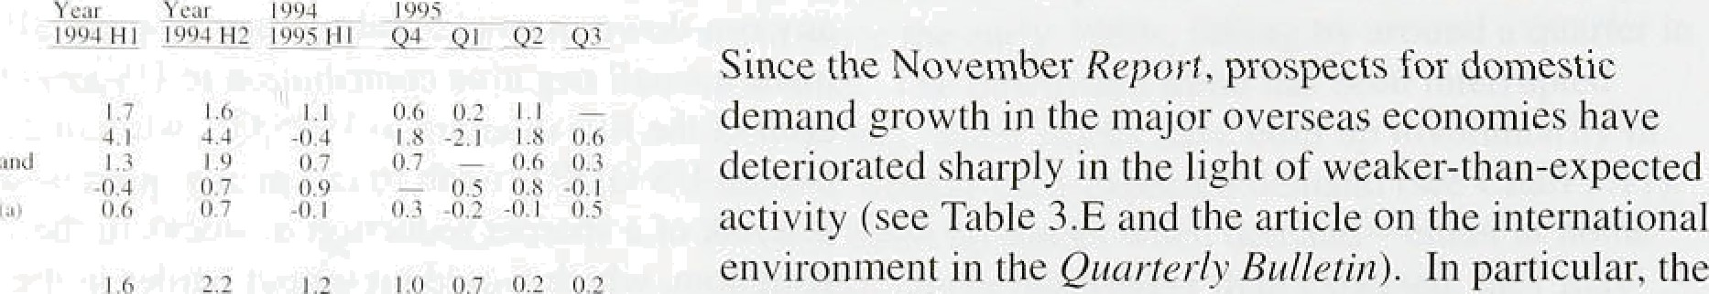

estimate of four-quarter GDP growth in the United States in 1995 Q3 was revised down .from .2.3 % to I.9% and, i.ri Jupan. GDP is estimated to have fallen by 0.2% in. the year to 199a Q3. .French and German four-quarter GDP growth also declined between the second and third c{uarters of 1995. As a result. forecasters scaled down their projections O.f growth in..the major i!ndustrialiseñ countries in 1996 and 1997.



! ’/ '|



UK exports have tended in the past to grow a .Iittle faster than domestic demand in the .major industrialised economies, for a giveri level of competiti.veness. The US economy appears to be on. course to grow,at around its

.long-run trend rate in 1996. but the course of French and German output and demand is l!ess certai.n. The future path.!of UK exports. will. partly depend, therefore, on. why domestic demand growth. irr.European ,economies slowed. Thé f31l ifi Gerinan,ând French growth could. have.some common causes., The article. on international sa.ving and investinent in,the *Qitnrterly B!ulletin* notes

.that long.-term real interest.Fates,in lthe GPIO rose significanil.y duri.ug!‘’1.594, reaching historically high

.levels, before failing fiack a little.in t9SS. This rim1.in.



the’ downturn .i.n.Europe iri.,1995. Conversely, tne drop i:fi real.rates. last yea:r cou:ld help to siiriiulale demand,



Chart 3.12





— 110

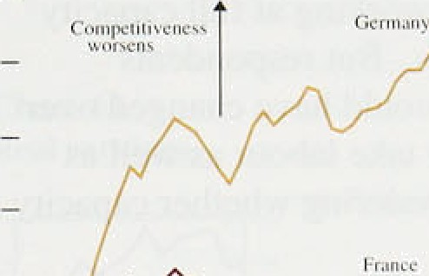

growth in 1996, although the changes in interest rates themselves could have partly been determined by changing expectations of future growth. Other possible explanations for the.Europe-wide slowdown include fiscal tightening and an appreciation of real exchange rates. But country-specific factors cannot be excluded. In 1995, France’s fiscal policy was tightened, while the social security reforms led to strikes and a drop in consumer spending in the third quarter. In Germany, a

sharp appreciation of the real exchange rate in 1994 and

###### 1995 (see Chart 3.12) exacerbated the downturn. So the

_ „ prospects for UK export growth in 1996 will partly

###### depend on the ,success of the French and German

„ ^ authorities’ measures to stimulate demand.



**Chart 3.15**

**Relative** demand **and** costs‹•›



One factor helping UK exports will be increased export

profitability, resulting from sterling’s depreciation during the first quarter of 1995 (see Chart 3.13). This has provided an incentive for firms to shift resources from



,«, , the domestic market into the export sector.

,$ Nevertheless, growth in UK export volumes is likely to

— i be lower than envisaged In November, and the risk to ’°' activity in 1996 from this source is probably on the

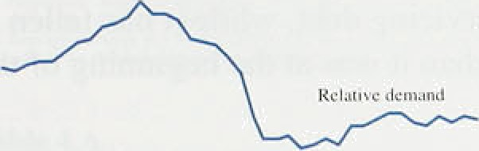

'

„ downside.

p “ 3 4 O t

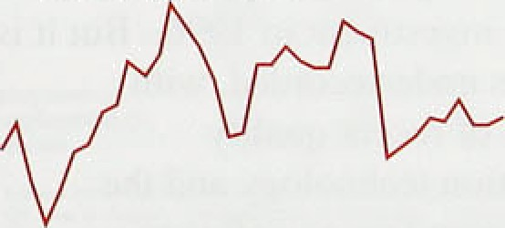



UK output is estimated to have increased by 0.49a in

* 1995 Q4. Estimated GDP growth was revised down

^ from 0.5% to 0.4'7o in 1995 Q3 and non-oil GDP growth

_„ from 0.59 to 0.39r. The estimated profile of output over

* 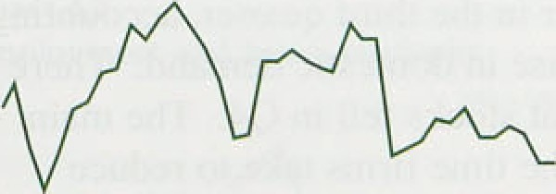« the past two years has been changed by successive '”' ' u› revisions to the GDP data (see Section 6).

The shape of the recovery changed in 1995, as GDP growth slowed (see Chart 3.14). In the previous year.

.recovery was skewed towards manufacturing—with growth in the manufacturing sector of around 1'/who a quailer, compared with I to in the service sector. After slowing towards the end of 1994, manufacturing output growth paused in 1995 Ql, before recovering slightly in the following two quarters; it rose by 0.4&o in Q3. In the fourth quarter, manufacturing output fell by 0.2%.



Service-sector growth slowed .only slightly in 1995; it increased by an average of 0.7&o a quarter.

The rate at which the economy can grow over the short term; iwithout putting:upward pressure on inflation, is

.influenced by the ñegree of spare capacity in the eisonomy. CBI s:irveys!!suggest that the number of firms working below.capacity in.the manufaciuri:ng sector rose

.29’



L'hart .\. I4



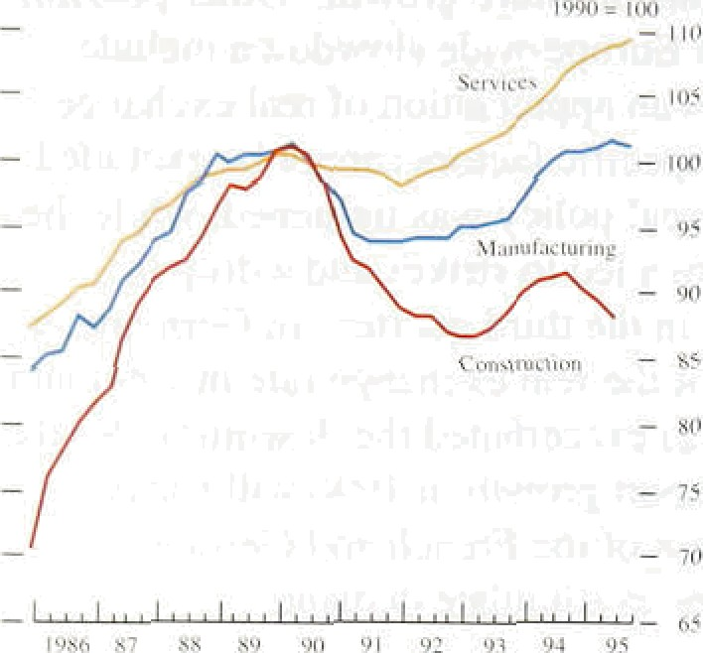

30

from around the middle of 1995, after falling during 1994 and the first half of 1995. But capacity utilisation remained at a historically high level. In contrast, the BCC Survey for 1995 Q4 reported more firms both in manufacturing anti services working at full capacity over the previous three months. But respondents' interpretation of full capacity could have changed over the past ten years if firms now take labour as well as capital into account when considering whether capacity is being used fully.

S3MS

Domestic demand, excluding stockbuilding. grew at.an average of 0.49r a quarter.in the first three quarters of 1995. Consumption grew .around its tre*d, as it has done since the beginning of 1994. Consumers’ net wealth will become more liquid after more building societies merge and convert to plc status over the next two years; they will also gain from one-off electricity rebates. .But both. consumption and debt remain high as a proportion of GDP, and the cost of servicing debt, while it has fallen recently, is still higher than it was at .the beginning of the l980s,

Investment fell unexpectedly in the third quarter of 1995, with construction investment particularly weak. This could continue to depress investment in 1996., But it is possible that investment is underrecorded, with insufficient account taken of recent quality improvements in inforiiiation technology an‹J the increasing importance of spending on software.

Stocks increased further in the third ,quarter, accounting for just under half tlie .rise in domestic demand. There are some indications that stocks fell in .Q4. The .main uncertainty surrounds tlie time firms take to reduce. stocks to desired levels.

Confidence about future export orderG fe1} sharply in the. fourth quaner, as European demand.contrasted. A rebound in European,eonsumption growth in 19.96 could lead to a sharp rise in the demaiid for.UK goods.., But, there is a risk Sof,the. *grow* th in export orders falling further.

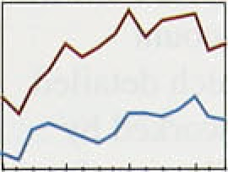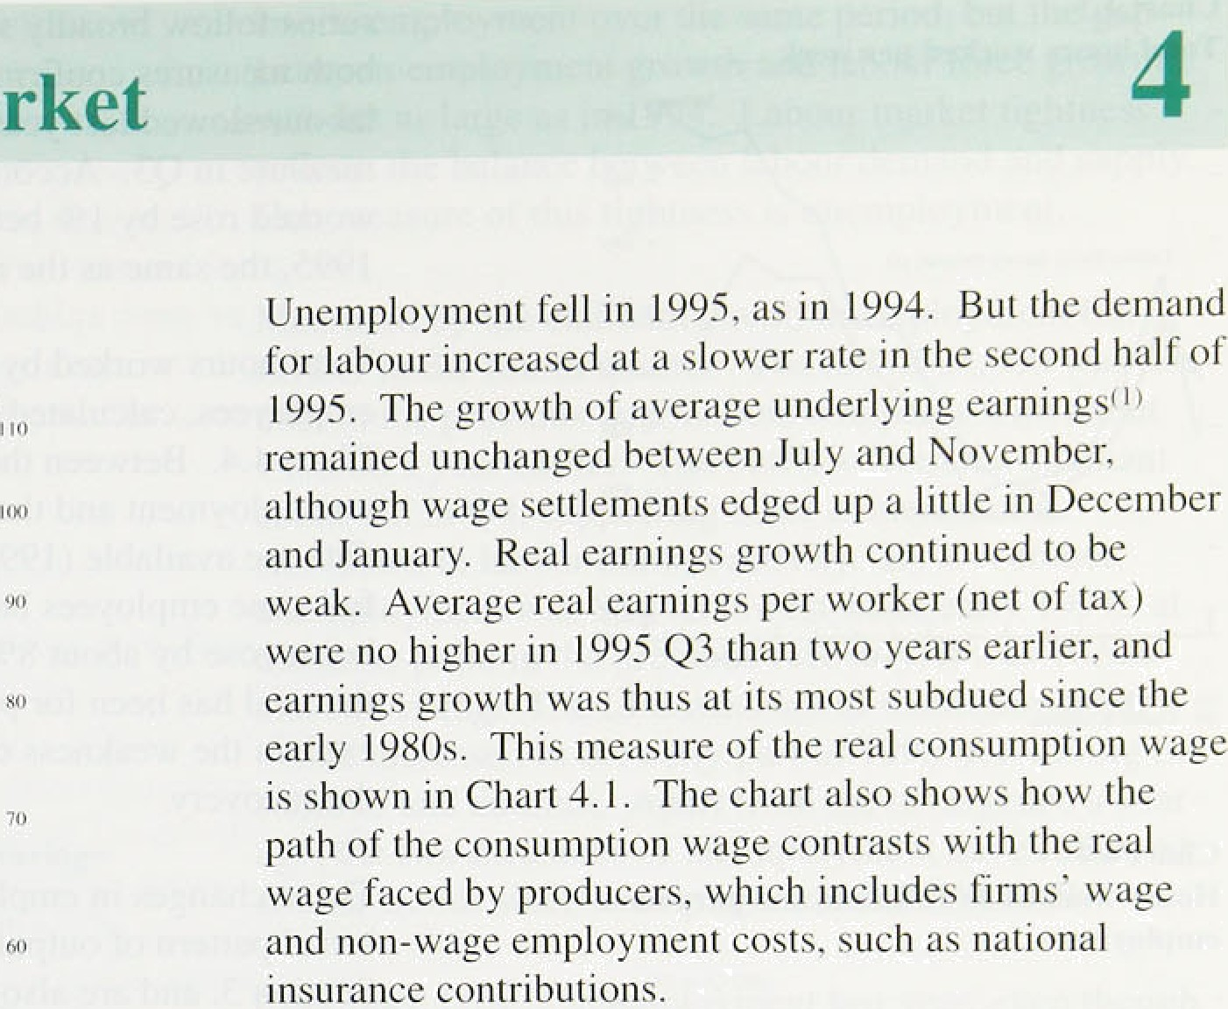

C%rt 4.1

**Real earnings**

4.1

Demand for labour

Table 4.A

**Labour market activity**

Chongen over penod shown; thriuiands

t994 1.995

Q4 Q1 g2 Q3 'Q4



Unemployment (bl . - I -72 -33 .48 -28

acmc%’ ” i2 -5. 6 13 ’-J

..(a} *'Latx›ur Force Run'.e}; .Q.! refers to /Doccmbcr to;Febw ;*’. Q2'Mamk io Msy;



**Chert 4.2**

Employment and hours worked‹•i

- I lO







The demand for labour has probably increased further since the November *Report.* Employment in Great Britain, measured by the Labour Force Survey (LFS), rose by 0.1% in 1995 Q a less rapid rise than for most of.tlie previous year (see Table 4.A).

Because of the growth in part-time and flexible working, the total number of employed workers is not the best measure of labour demand. Total hours worked in the economy is a more comprehensive measure, and the CSO.published a new measure of total hours worked in December. It combines average hours data from.the LFS with emplooyment data from the

workforce-in-employment (WIE) survey.(* Chart 4.2 shows!that, .during the recent recession, hours worked fell more sharply than employment. Since 1993, total hours worked have risen more rapidly than employment despite a rise in part-time work because, in the short lerin, firms .adjust hours worked per employee as well as employment in response to changes in demand for their prq‹iucts.

##### The. new!series for hours worked is riot yet avai.lable beyon‹i 1995 Q3,'but’the LFS provides a more

up-to-date estimate of total hours worked. The tivo



.(2). The neuz'seiies is:.des,cribed. in mom:detai1 on'pages 467-76 of £ Your







Chan 4ñ

**Yt›tat tuiurs w'urked per weeh**

_ Sjillion› $p

— - M*

* I qi«'oi For':c Sv r•'c - meet re I s i * “' '

series follow broadly similar trends, as Chart 4.3 shows; both measures confirm that growth in the demand .for labour slowed last year,!with a.sharp fall in.the.new measure in Q3. According to the LFS, total hours worked rose by I 9• between autumn 1994 and autumn 1995, the same as the rise in employment.



C“h:i rt 4.fi

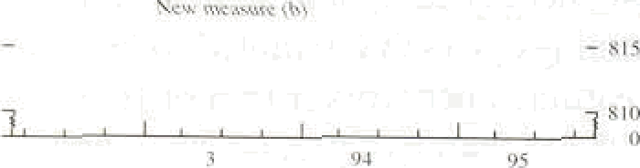— 8*0

Total hours worked by part-time and full-time employees, calculated using the new .series, are shown in Chart 4.4. Between the peak in claimant-count unemployment and the latest point for which detailed data are available (1995 Q3), total hours worked by

full-time employees barely increased, while part-time hours rose by about 8%. Much of the growth in labour demand has been for part-time employees: this helps to explain the weakness of weekly earnings growth during the recovery.

Hours wormed bt t’ulI-time and part-lime



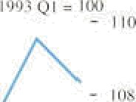



These changes in employment are consistent with the broad pattern of output growth in 1995, reported in Section 3, and are also illustrated by survey data. In the January 1996 **CBI** Quarterly Industrial Trends Survey, a balance of 17&o of.manufacturers expected .to cut employment in the following four months. The CiPS employment index, which had been around 50 in the second lialf of last year, fell sharply in January, perhaps indicating that the rise in manufacturing employment was coming to an end. By contrast, the January BCC Survey reported a net positive balance of service companies still anticipating a rise in employment in Q1, although fewer than in Q4.

Other indicators also suggested slower growth in labour demand. For example, vacancies at Jobcentres—whicii account for about a third of all vacancie wefe roughly unchanged in .Q4 (see Table.4.A),,although still at their highest since: early 1990. The ratio of va:cancies to. unemployment rose.further last.year,; wliich could indicate greater.mismatch betweeri labour demand and supply.

**4.2 Labour marRet tightness, and**

e en**t**

##### Although the fiemaiid’fpr 1abour‹co tinued /to rise last y,ear, so.‹rid the supply. .In the year to November, the

.fiumber of people. aged 1.6!.or over.either in: employment

##### or seeking word rose by 0.3.&o: Th!is.was:1esa:then’the



*The labour in rat*

rise in employment over the same period, but the gap between employment growth and labour force growth was not as large as in 1994. LabolJr market tightness reflects the balance between labour demand and supply.

One measure of this tightness is unemployment.

**Chart 4.5**

**Changes in overtime huurs in manufacturing** *

Measured by the claimant count, unemployment fell further in the fourth .quarter. The fall of 28,000 was less than in the previous quarter. and compares with about 140,000 a year.earlier. The outflow from the claimant count fell in Q4, supporting other evidence .of a slowdown in labour market activity. By December, unemployment was 8%, its lowest since early 1991: at the same poinl in the previous recovery. it was 10.9% and still rising. The LFS measure of unemployment, which increased in the early part of 1995, fell during the summer and autumn. Apart from the divergence a year ago, the two measures of unemployment have followed similar trends since unemployment started to fall.

- —10

’.’l99Z’ 93^ .94 ’95



**Chart 4.6**

**tJneinp**









Continued falls in unemployment last year, even though they were smaller than a year earlier, were a little surprising given the slowdown in output growth. But changes in employment depend on both current and past changes in output. Initially, firms probably responded to the sharp rise in output in 1994 by increasing overtime and shift work, because they were unsure whether higher demand would persist, especially if much of it came from new markets overseas. For example, overtime work in manufacturing increased sharply toward the end of l9S4, as Chart 4.5 shows, but stabilised toward the end of 1995, and hours worked rose by more than employment in the early part of the recovery. as reported earlier. Despite the slowdown in output growth in 1995.

.firms seem to have taken the view that higher output was not transitory and so increased employment. In the past. employment has adjusted to output over the course of

* about a year.

The inactivity rate, defined as the percentage of people aged lfi or over neither in work nor actively seeking work;.is another measure.of labour market tightness.. And,.as.Chart4.6 shows, the proportion of the population.defined as economically inactive fell a little last year. :Oxerall, however, the inactivity rate has fallen Very liit!e ñuring.the recovery, because of increases in the numbers of students and of those claiming invalidity atid loñg-term sickness benefit. to explain the divergence,between iaaeti.vity:and u:netnployment rates in the:chyt the.in tivity.rate probably understates the. ttghtening.of the lalsour inarket:



33

lntitili‹›n Rep‹›rt: Pehiuur2' 190t





t’h:ml 4.8



Scre ice-secttir earnings **gr‹ru th**







|9V" 03’ B4 95



’r«ble 4.B

¥¥age settlements

Pe ntagcs

Whole-economy m«diuo For three nionrhx e'nding:



Skill shortages are also an indicator of labnur market tightness. Surv,eys provide conflicting eVidence. The BCC Survey reported greater recruitment difficulties in both manufacturing and service companies in the final quarter of last year. But in January .the CBI’s Quarterly Industrial Trends Survey reported that skilled labour shortages were unlikely to limit output much over the coming four months. with the outlook the same as during most of last year.

4 a s

The growth of nominal underlying average earnings per worker was 3'hon in November, uiichanged from the November *Report.* Earnings growth started to fall in manufacturing in early 1995 and in the service sector in early 1994 (see Chart 4.7). Continued low

service-sector earnings growth was not the result of low demand: part of the explanation is that much of the employment growth was in part-time jobs. .For example, in the year to 1995 Q3, employment in the hotel and restaurant sector, in which .more than a half of employees are part time, rose by about 4%, and for most of 1994 and 1995 earnings growth per worker in.that

, sector was less than in the services sector overall. Pay restraint in the public sector also helps to account for

* weak service-sector earnings, as Chart 4.8 shows.

Pay settlements for the whole economy continued at around 3.% u:nti! October.last year.. .Since théfi,. tliey have. risen. Table 4.B shows a variety of settlement.measures. About four fifths of pay reviews,.occur in the first seven months of the year; so settlement measures in.the second half of the



out1!iers. The. Bank’s preferred measure.of settlements, reported. in the table, is weighted.•fiy employment and based on data supplied by the!CBI:, IDS,.I:RS,. LRD and the Bank’s Agentsl.

###### About.a fi.fth of all settlements: occur in.January,

.covering about a tenth.of:enipl'o.yess: ..Only about 157

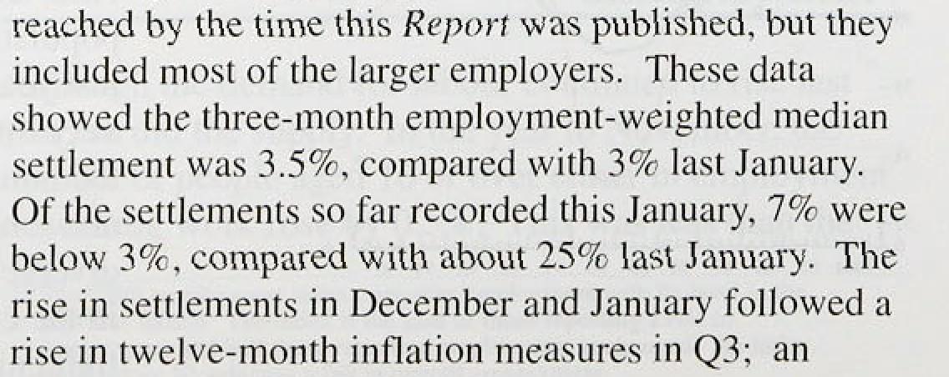



|  |  |  |
| --- | --- | --- |
| 1RS‹<› | 3.0 | 3.P |
| LRD\J› | 3.0 | 3..0 |
| Bank.‹•i | 3.0 | 3.0 |



3.0'—3:9'





:easing in inflationary pressures in the coming months



.may help.to reduce upward pressure on settlements.







**Chart 4.10**

Changes in real earnlng'i•› and unemployment



gun’.o’yAz eorlie

10:O-



’7:5:-’

Earnings generally grow more quickly than wage settlements because factors such as overtime, bonus payments and grading increases, rise faster—the difference is known as 'wage drift’. The November fieporfnoted the fall in earnings growth during the summer and the disappearance of wage drift. Wage drift remained .negligible in the three months to November.

Between 1991 and l9fi5, wage drift in manufacturing and:service sectors fell, as Chart 4.9 shows.

Service-sector wage drift was negative from mid-1994 to the third lquarter of 1995, though services earnings rose relative to settlements in October and November. Low wage drift in service industries over the past four years partly reflected growing part-time employment, which cut average weekly earnings per worker, as well as reducing overtime payments. Lower bonuses in the

.financial sector also accounted for low service-sector wage drift in the early part of last year. though bonuses were high in 1993 and 1994 and so cannot explain the fall in drift since 1992. In 1995, equity and bond markets were .generally much stronger than in 1994, so



0.0-



i financial-sector bonuses to be paid in the first quarter of this year could be much higher. leading to a temporary rise in wage drift in the service sector.



u„„„,p„ '" Real earnings growth was subdued last year, despite the

###### '"°*i•" *' - „ continued tightening in the labour market. Chart 4.10

shows how, until about 1990, changes in unemployment

" were usually negatively correlated with real earnings grtiwth (defined here as growth in the real consumption wage). Between 1956 and 1992 Q the previous peak iri uneemmployment—the correlation between annual



**Uneñiploymeiit arid real Earnings:**

rolling correlations›

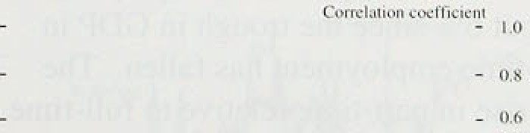





in unemployment and real earnings was about

-0.3. One explanation for this might be that in the short run, as unemployment falls, workers have greater leverage to push for hi.gher real wages, because the diminishing pool of unemployed puts less downward pressure on wages. Since the beginning of 1993, unemployment has fallen steadily, but real earnings have barely .increased. It .is too early to be certain. but it is possible that the relationship between real earnings and unemployment has changed. Chart 4,11 shows that the ”short-nin correlation between changes in unemployment and real eamihgs has shifted around over the past



30 years or so. Between tire mid-t970s’ and early- l9S0s the'eorre1ation was negative, but it has changed in the recent past. This,might’reflect the gradual impact of

eh nges,to labour market institutions ,and to the



li fJtiti‹›n Rct›‹›rt: Fahr‹i; r} 1 09h _

###### composition of employment and unemployment, leading to a fall in the level .of unemployment consistent with stable wage inflation, for a given monetary stance.

e4g4o

h has rea w

th ee ow







— 30

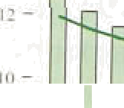





Tahle 4.C

£ rnwth in f'ul)-time and part-time wnrk uver the recovery‹•›

Labour Furrc Surge} r w or r £ t ›

Full-time Part-time Full-time





###### The main institutional factors affecting the natural .rate of unemployment during the 1980s and l990s were changes tn the wage-bargaining and benefit systems and the effects of the labour market legislation of the 1980s. Unemployment benefit became progressively less generous during the l980s; the ratio of benefits to earnings—the replacement ratio—fell, with the proportion of the working population whose replacement ratio was below 0.7 rising from about 859a in 1985 to 95' • by 1995. The tightening of

benefit-eligibility criteria, and the introduction of programmes such as RESTART and youth training also increased the attractiveness of work relative to unemployment and therefore increased:the competitive pressure on wages for a glven level of unemployment.

The role of trade unions also changed. Legislation reduced their power. The percentage of employees covered by collective.bargaining fell .from about 70% in 1984 to around 50&• in 1990, with more wage deals struck at local rather than industry .level. And the plercentage of workers who .were members of trade unions also fell, from 50a in 1980 to 32&a in 1954 (see Chart 4.12). Most of these!reforms to the bargai.ning framework made wages more flexible for a given. ley.e1 of unemployment,



According to the WIE measure, p1aft-time..employment has increased by about 6&• since the trough in GDP in l992tQ I, while full-time employment has fallen. The LFS also reported a rise..i!n part-tilneirelati.ve. to full-time. work, as Table 4.C shows. The.spread of part-time and

.short-term.contract work,. concentrated particularly in less unionised service-sector industr,ies, has reduced. workers' wage-bargaining strength. It has also probably



contrast.workqrs .area.not:.coyered as fuliy'by;statutory employment protection.



'.week... Ectiina,tei .Assuzrte f'u.It.fetciptyE.be.oafifi:.UttitkraenL.and aro.based..







**Num%r of.penpte making,ot least**



 Pcrccnlnge of



t98s-69 9.70

I9ft6-90 .9:47

The distribution and duration of unemployment also affect bargaining. Unemployment became more widespread across occupations during the l990s, with historically relatively high redundancy rates among non-manual workers. So job insecurity may .have become more widespread. But the proportion of the population with some recent experience of

f98&-9.2 9..?G

1989-9? 9.79.

1990-.94 'IU.22

1991-95 10.39

';S4urce: .Supplied io be 8ank 6y i he CSO,

(zl GrulBñmiu

2

’’ ‹’; 27:4

273

unemployment has not changed much, as Table 4.D shows. The average duration of unemployment, however, rose sharply in the 1980s, with the proportion of those unemployed for more than a year

rising from about 30% in 1980 to a peak of nearly 459a

(bi Añcs da+QsEoolJ tell*«d’w crGmac•:%n‹:rt#opopul:uioooI•vorCing

vgvov, IHc:G'm-p"zrp$ned*he dccnciiin i‹•0.

**Chart 4.13**

**Productivity growth over the cyclei•'**







- 0

0 I' 2 3' 4: '* 6' '7 8 9 10 I I ) 2 i 3' 14 I5 '



\csthn' n' iiui:eve the insurer'in'• h 'ch il•: irsot;fi in cpu w.

(a)' Mlns)Cononty. ouipui per tead'

in 1987. The share fell in the early 1990s, but was back up to 38% in 1995. The long-term unemployed are likely to exert less downward pressure on wages, since in some cases their skills have deteriorated. making them less attractive to potential employers. So the

increase in the proportion of long-term unemployment is one of the few developments likely to have put upward pressure on the natural rate of unemployment in the recent past.

In.all probability, the natural rate has fallen over the past decade, although estimates of it vary widely.

Institutional changes have reduced rigidities in the wage-bargaining framework. and the changing nature of employment has reduced the willingness of workers to push for higher wages for a given level of unemployment. The weakness of earnings growth during the recent recovery is consistent with unemployment being above its natural rate.

### 5 P ti it nd u t a e c

**Chart 4:14**

Relative unit .wage costst•›



The growth in productivity per head slowed down in the second half of last year and unit wage costs accelerated.

'é i i A lot of this change was cyclical, as employment growth ‘caught up’ with the sharp rise in output in 1994.



'“ Chart 4.13 shows how productivity growth also fell a

,p fed years into the previous two recoveries; the fall in this recovery has so far been less sharp. Last year’s rise

" in unit wage costs needs to be seen in this context.

##### Chart 4.14 shows that. measured in local currency terms, manufacturing unit wage costs in the United Kingdom have increased over the past two years relative to those of its inajo competitors, This reducñon .in underlying. labour-com competitiveness eroded only some of the fall



”









4 6 S

The labour market continued to tighten, despite the slowdown in output growth in the second half of last year. Employment was probably 'catching up’ with high output growth earlier in the recovery. Most of the growth in employment continued to be in part-time work. Earnings growth remained subdued.

Unemployment is currently above its natural rate. That rate has probably fallen over the past ten years.

38

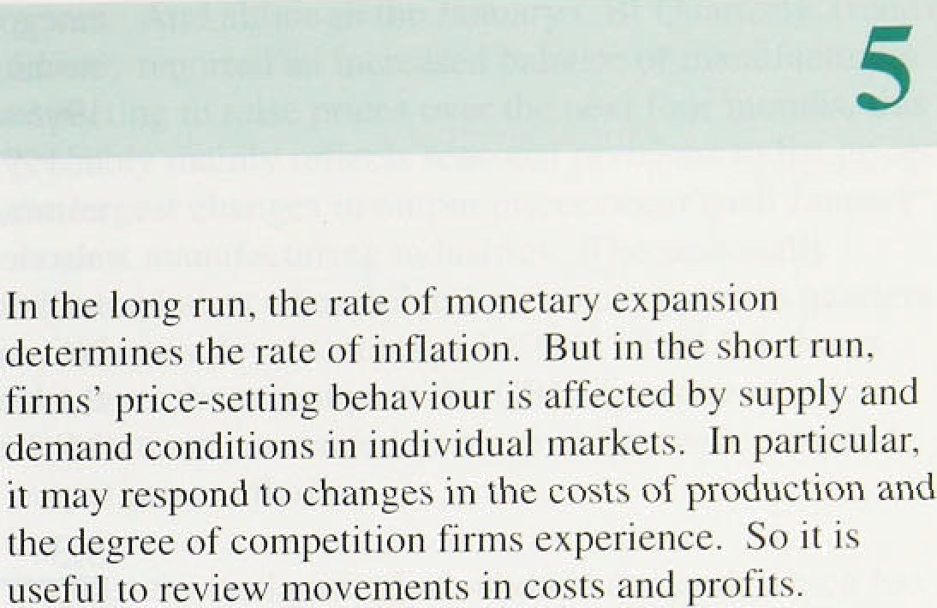

Tible 5,A.

**Contrlbutiiins to changes in the Bank’s commodity price index‹** ›‹•›

1994 ' 1995

¿Q4 Q Q2 Q3 Oct. Nov. Dec.

Aft.: 6,3 III,7 fi.fi 2. I 3.6 2.0 2.7

















#### 1 R ateri d c d t es

The Bank’s commodity price index rose by I.I % in Q4, after .falling by 2.1% in Q3. In the twelve months to December, the .index increased by 2.7%. compared with annual rates of over l09r in the first quarter of 1995.

The increase in the year to December was entirely

.accounted for by higher prices for oil and indigenous

.agricultural products such as cereals, milk and livestock (see Table 5.A). Tight supply conditions in world cereals markets may continue to put upward pressure on agricultural prices, at least in the short term.

Oil prices rose in the final quarter of last year. The price of Brent crude increased from a monthly average of around $16 per barrel in October to around $17'/• per barrel in December. Temporary factor have been important, such as the increased demand resulting from cold weather in Europe and North America at the end of last year. The upward momentum has not continued into 1996: by 9 February, the price of Brent crude had fallen back.close to $16'/‹ per barrel.



ImPOIt prices continued to1 rise in the third and into the fourih quarter of 1995, but more slowly than earlier in the year. In the three months to November, non-oil iniport prices rose by 1.3%, compared wfth the previous lthree months. This followed .increases of 6.7%, 2.59c, ’and .I.47c in Q1, .Q2 and Q3 respectively. The more

tiiiiely. stdtistics.for i!mport prices from non-EU countries show a pattern’ si.nii.lar to that of the overall index,

.though.the price increases have beem smaller. Non-oil

.impart’prices!fr0m..non-.EU. countries rose by .0.2% in Q4,:after.iiaing by ,0.9 .in. both Q3 and Q2. As shown **in!.Chart** 5.l„.the..slowdown occutrtd for all three major

'.39



categories of impons. The.relatixe stability of.the sterling effective exchange rate in the second half pt 1995 was.a factor; almost all of the 6!/‹ fall in, sterling in 1995 occurred in the first half of the year. Softer commodity prices and slower demand growth overseas also led to a modest slowdown in producer price inflation in the rest of the G7 countries. In the year to November, average producer prices in ,the G7 excluding the United Kingdom increased by 2.0& , compared with 2.89c in the yenr to June.

L'hni I 4.2

**J°ruduccr input price inflation**





### I5n3t n t t es

Producer input price inflation has moderated further since the November *Report.* In Q4, the prices paid by manufacturers for fuel and materials rose by 0.39n, compared with 1.1% in Q3. And in January input prices fell by 0.39r, bringing the twelve-month growth rate down to 4.0%, the lowest rate since.July 1994, Oil

* prices fed through quickly to the materials prices
* included in the producer input price index, after rising towards the end of last year: the crude oil component of

, the index, which reflects movements in Brent crude prices, rose by 7.39• in December and by 5.59a in

* January. But, offsetting this, other material costs have ' continued to increase more slowly, reflecting weaker

commodity prices and import costs. In the twelve monfhs to January, material prices as a whole rose by 5.6&c, compared with a rate of I 1.49c in September.

Fuel costs—principally electricity anal gas (and excluding crude oil)—have fallen fairly steadily for well over a year, and have also contributed to slower input price inflation (see .Chart 5.2).

Survey evidence also indicates that input cost pressures have eased. The CIPS .Survey’s price index of purchases fell for seven consecutive months during .1995 and since December has stabilised just below 50, suggesting input prices are broadly flat. This is consistent with reports from the Bank’s Agents.

Output.price inflation, trio, has wea:keoed since the November *Report.* Exclutli:ng the often.volatile food, drink,. tobacco and:petroleum.prices, ou:tput prices:rose by 0:.6&• in Q4. This is atounfi.half tñe Average increase in the:first three quarters of last:year. .And.4n:January, these:'core’ output.prices were! changed on. December.: Asda result, .the threamonth annufl1iseñ1rate:of inenase fell further to 1'.7 ;. eoinpatefi with 4.â&.in September. añd4.9& ln June:: It.seenu !ikely that:inost of the rise in' input costs.earlier’in 1993 hon fed through to outputs

*P*r*i*cjrfg *@,linviour*

**Cbart SJ**

**Producer, ouiput price inflation.and CBS price**

ezpectatlo a

 

]O- ’ - lO.O

prices. And although the January CBI Quarterly Trends Survey reported an increased balance of manufacturers expecting to raise prices over the next four months, this probably mainly reflects seasonal revisions to list prices: the largest changes in output prices occur each January

„ in most manufacturing industries. The seasonally adjusted balance has fallen for two consecutive quarters



- ,» to its lowest level since April 1994. Chart 5.3 shows tkat, over the recent past, the CBI’s measure of price

— .expectations has tended to move in line with recorded output price inflation.







**Chart5.4**

**Producer output price inflation**





— — 0

1992 83 S# 9S 9d





Against the background of subdued demand, which has

” probably contributed to the build-up of stocks in the

, , manufacturing sector, the ability of firms to pass on cost increases seems to have weakened. As Chart 5.4 shows, the gross( I measure of annual output price inflation has generally fallen by more than the net measure since the middle of last year, suggesting that cosl pressures are to some extent being absorbed within the manufacturing sector. The Bank's Agents reported continued, and in some cases intensifying, customer resistance to price rises, and not only in those sectors close to final consumer demand.

### 5.4 Labour costs

As discussed in Section 4, earnings growth has so far remained surprisingly low. Despite this, unit wage eosts continued to increase more rapidly: in manufacturing they rose by 4.19 in the year to November, and for the economy as a whole by 0.8% in the year to Q3. This reflects a rise in employment at a time of slower output growth; in manufacturing, productivity even fell by 0.5& in the twelve months to November.

Actual unit labeur costs may be a poor guide to pressures on firms to increase output prices because of cyclical movements in productivity. For example, a downward shock to demand is likely to raise unit labour costs given the fixed cost of plant, but firms’ price response may be to reduce prices to attract demand from

###### .c.ompeiitors. More generally. firms’ output, employment



aid pricing decisions are determined jointly in order .to

.aei;ieve a.desired level of profitability. But in the short o„there are costs to adjusting employment and plant. In, i9 long run. firms are able to adjust fully all factors

pi’oductivity trends in order to interpret movements in firms’ labour costs. Chart 5.5 shows estimates of the trends in productivity growth for manufacturing and the whole economy—these have not declined over the past year. Coupled with subdued growth in earnings, this suggests that there was little increase in labour cost pre.ssiires in 1995. This is consistent with the January CBI Industrial Trends Survey, which reported a balance o1’ 25% of respondents reporting increased unit costs over the previous four months, slightly lower than the 26% in October’ and 29'7r in July.

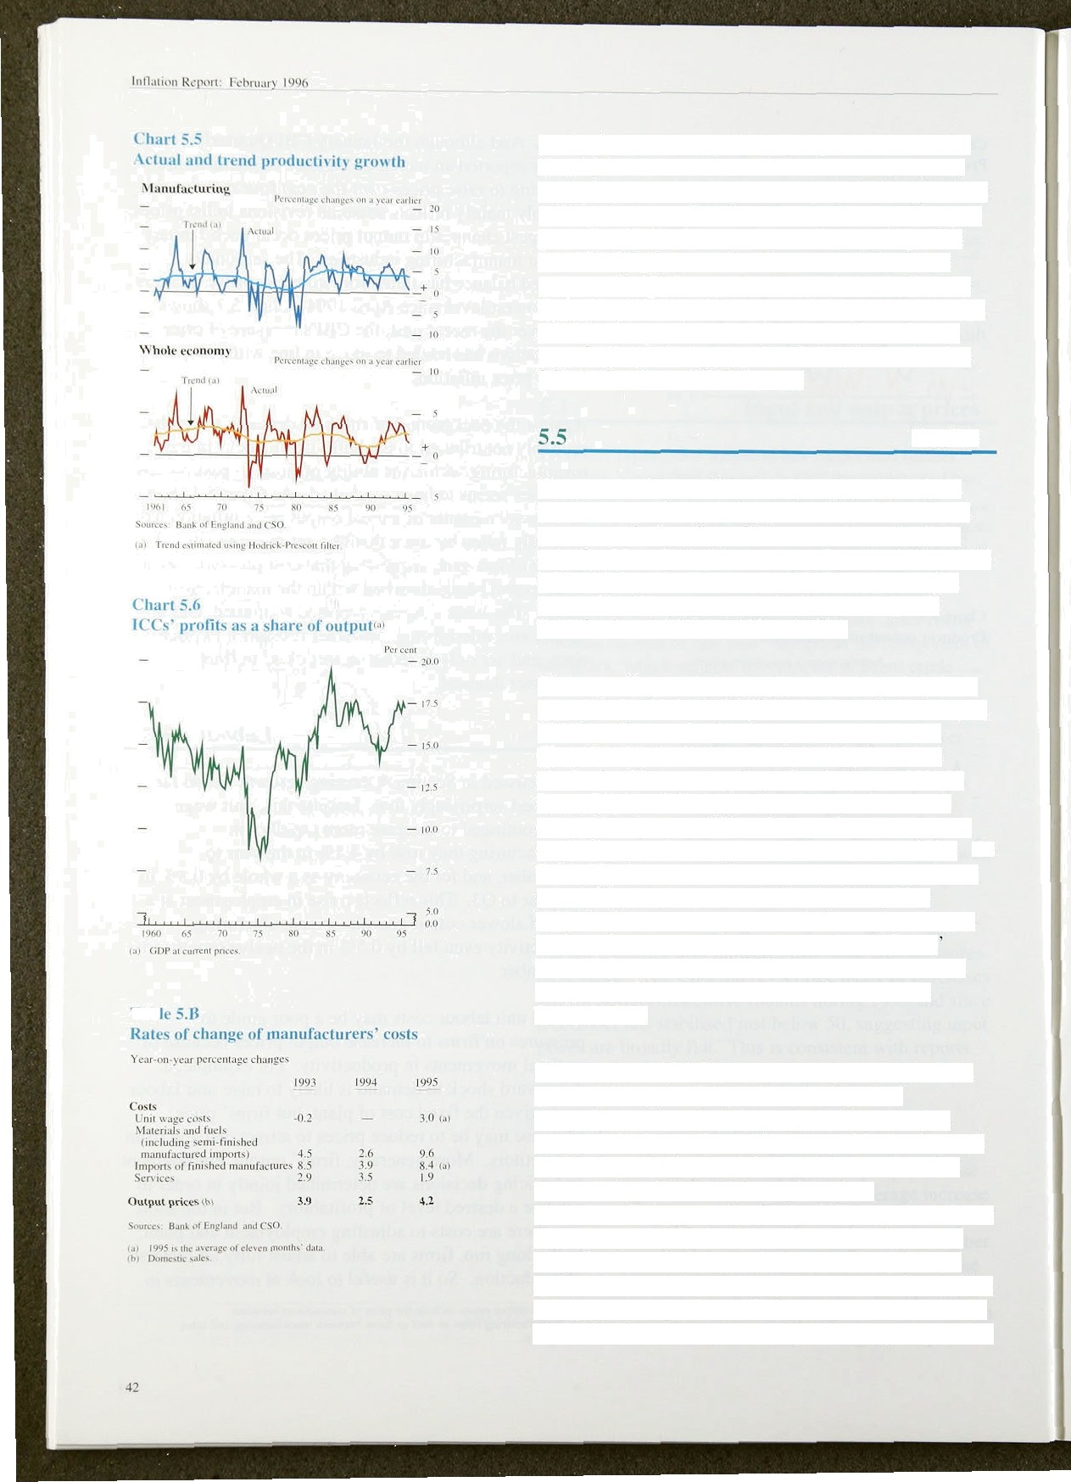

Profits

The gross trading profits of ICCs fell by 0.9% in Q3. This largely reflected a sharp tall in North Sea oil and gas companies’ profits, which tend to be particularly volatile. Non North Sea companies’ profits fell by 0.29• in the third quarter, but were still 5.6% higher than a year earlier. This contrasts with the rates of profit growth of over 10% in 1993 and 1994.

Slower profit growth has been related to the slowdown in output growth in 1995. But as a share of total output, ICCs’ profits remained as buoyant as in 1994, arid Chart 5.6 shows that this ratio is high by historical standards. The recovery in profits since the 1990—92 reces.sion should encourage importers and domestic competitors to enter UK markets, which may limit the

scope for widening margins. But sectors may differ. As Table 5.B shows, manufacturers’ costs, particularly for material inputs, increased rapidly in 1995, which suggests there was a squeeze on their margins. Export business has provided some relief: manufacturers

export prices rose by 13.3% in the year to November, compared with an increase of 5.89 in the year to January 1995.

The extent to which higher costs are passed on to final consumer prices will depend on the degree of competition. There have been significant structural changes which have intensified competition in the retail sector. In particular, large food retailers have shifted business into higher margin goods such as pharmaceuticals, speciality foods, DIY and petrol. More recently, retailers have begun to expand their product range further to include markets where margins were previously covered by price agreements—such as books, newspapers, magazines and non-prescription medicines. These developments are unlikely to be temporary, and so

##### may limit the degree to which past rises in retailers’

input costs can be passed to *the consumer.*

5 6 S

Inflation rates for both inputs and outputs in the manufacturing sector have fallen since the November *Report.* And impori prices are rising more slowly than earlier in the year, as the effects of the large fall in sterling and sharp commodity price rises in the first half of 1995 seem to have worked through. Offsetting these factors, unit wage costs continue to accelerate, although this largely reflects cyclical falls in productivity and so may have .only a modest influence. Increased competition in the retail sector has so far limited the extent to Which higher input costs have been passed through to final consumer prices.

*-RfJ'L' I( .i i ( t':.1. '•. . .- i :''.m

 

C’hurl fi.l

Rex’isions io **the pr‹›1ile of’ UDP** growlhi..«s›

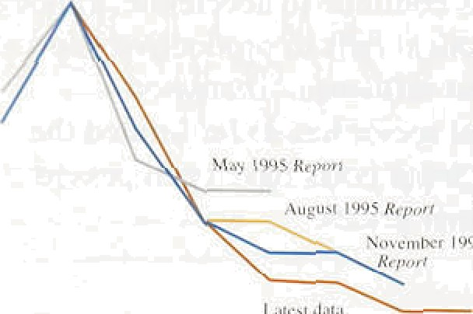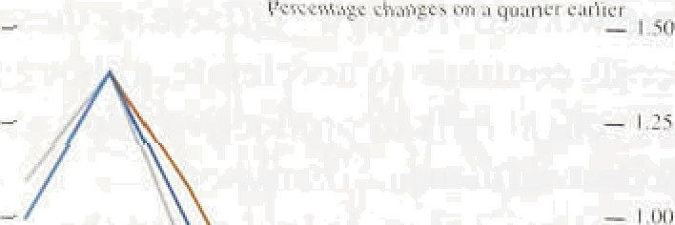





#### 1 he nk e te ec

It is now clear that economic growth.since the .end of 1994 has been slower than first thought. Chart 6.1 shows how the latest data reveal a slowdown that was much less evident at the time of the November *Inflation Report.* Three main factors were responsible. First, net exports were weaker than expected. UK export markets were affected by the slowdown, first in the United States. and later in Germany afid France. Second, investment growth was not as fast as projected, even relative to output. The conditions for more rapid investment growth had looke‹i favourable, judging

by surveys of business intentions, the high profitñbility and liquidity of the corporate sector, and the rise in

the stock market relative to the cost of investment goods. These indicators gave disproportionate weight to demand for investment goods by manufactu!rers,

and demand in other sectors„especially for.construction output, turned out to be much weaker. , Third,

although consumption was robust, much of the

increase was in spending on the National Lottery which in 1995 did not tratislate Into demand for UK goods and services.

The depreciation of sterling in the first quarter of 1995, and the continuing rise in commodity pnces, ha‹i a first-round impact during last year on the prices. of import.s, and tradable goods and•services more generally., The May *Inflation Report* explained that there.need be no second-roundiimpaet of tliese

developments on domestically set pricesland wages. The slowdown in demand last year, combined with the monetary policy stance; ensured that this was indee‹i the outcome..

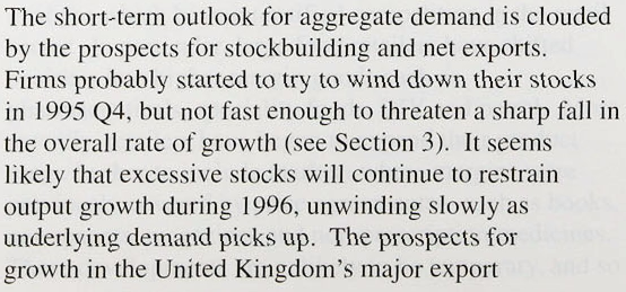

*Prosye is. or,iii'fIuIioy*

markets.have worsened in recent months particularly in Germany and Franc espite their cuts in

interest rates. The downside risk to activity is of more

rapid destocking, exacerbated by a decline in export

demand.

The medium-term prospects for aggregate demand depend less on stocks and .more on consumption, investment, and net exports. Section 3 pointed out that consumption has increased at around its long-run trend rate since the beginning of 1994. It is more

likely to speed up than slow down. Personal sector wealth will have begun to increase with the rise in

the value of the stock market and the stabilisation of house prices. Personal holdings of M4 have been rising relative to incomes, and real disposable incomes are likely to increase. The ‘windfall gains’ discussed in Section 3 present an upside risk but total consumption could still be held back by the

precautionary saving of those households still affected by high levels of debt.

The conditions necessary for more rapid investment growth still exist. In particular, rising investment has in the past been preceded by increased mergers and acquisitions activity, and by increases in ICCs’ borrowing and deposits, all of which were seen in 1995. For these reasons, our central projection is for investment growth to pick up, but there are substantial risks on both sides.

The prospects for net exports depend on the duration of the current slowdown elsewhere in Europe. Most of the gain in competitiveness in autumn 1992, as measured by

.relative unit labour costs, has been maintained, so the UK share of world mathets should hold up.

- Turning to the supply side, there are two main issues.

First, unemployment is almost certainly above its natural

!rate, !but how far is unknown. The Bank’s projection allows for some. pick-up in real earnings growth, in line. with the experience of the 1980s. But, if the natural rate

. , were lower, disinflationary pressures throughout the forecast period .would be stronger. Second, the central projection assumes that retail margins remain at around their current levels. The risks are probably on the upside.

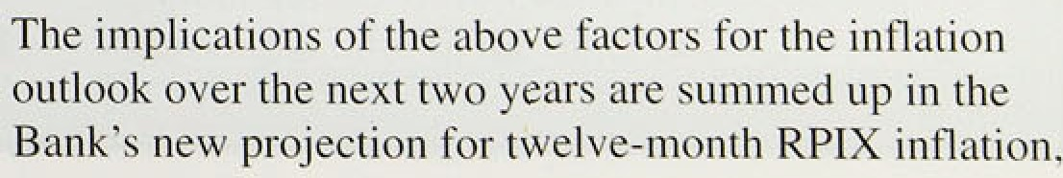

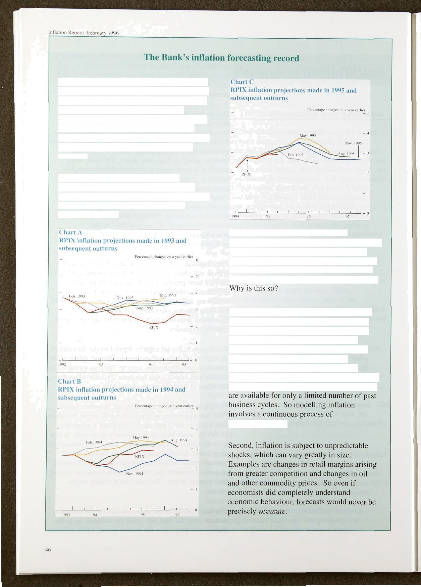

There can be no escape from forecasting in the condiict of monetary policy. The reason is that it takes about two years for changes in interest

rates to have their maximuml impact on

inflation, so it is necessary to form a judgment about inflation two years ahead in order to guide policy. But in the past inflation forecasts have rarely coincided with the subsequent oincome.

A simple way t›f assessing the Bank’s forecasting record is to compare its central projection of inflation two years ahead with the actual inflation outturn. This is done in

Charts A, B and C.

These show that most of the inflation projections made by the Bank in 1993 and 1994 proved too high. while those made in 1995, appear. so far. to be closer to the path of actual inflation. But this is not a sufficient criterion against which to judge the Bank’s track record.

Inflation, like other economic phenomena, is inherently uncertain. The uncertainty arises from two sources. First, the economy is too complex and too rapidly changing for its behaviour to be captured in any fixed set of equations or ‘model’ of the economy.

Nevertheless, past experience is the only available guide to the quantitative relationships between the key economic variables; and data

learning-by-doing.

**Since** future inflation cannot be known \fjth certainty, any coherent projection is a probability distribution and not a point estimate. Despite that, many. though not all, forecasts are published as single numbers. So the Bank has obtained from 38 outside forecasters the probabilities which they attach to inflation falling within certain ranges. These are published for the first time in this *Report.* As the first /n9ofion *Report* in February 1993 emphasised, it would ‘be unwise to base policy on the wholly spurious precision of a point forecast’. In presenting its projections, the Bank has always discussed the risks—both in size and direction—to the central projection. A new way of illustrating the probability distribution as a whole is introduced in the *Report* in Chart 6.2.

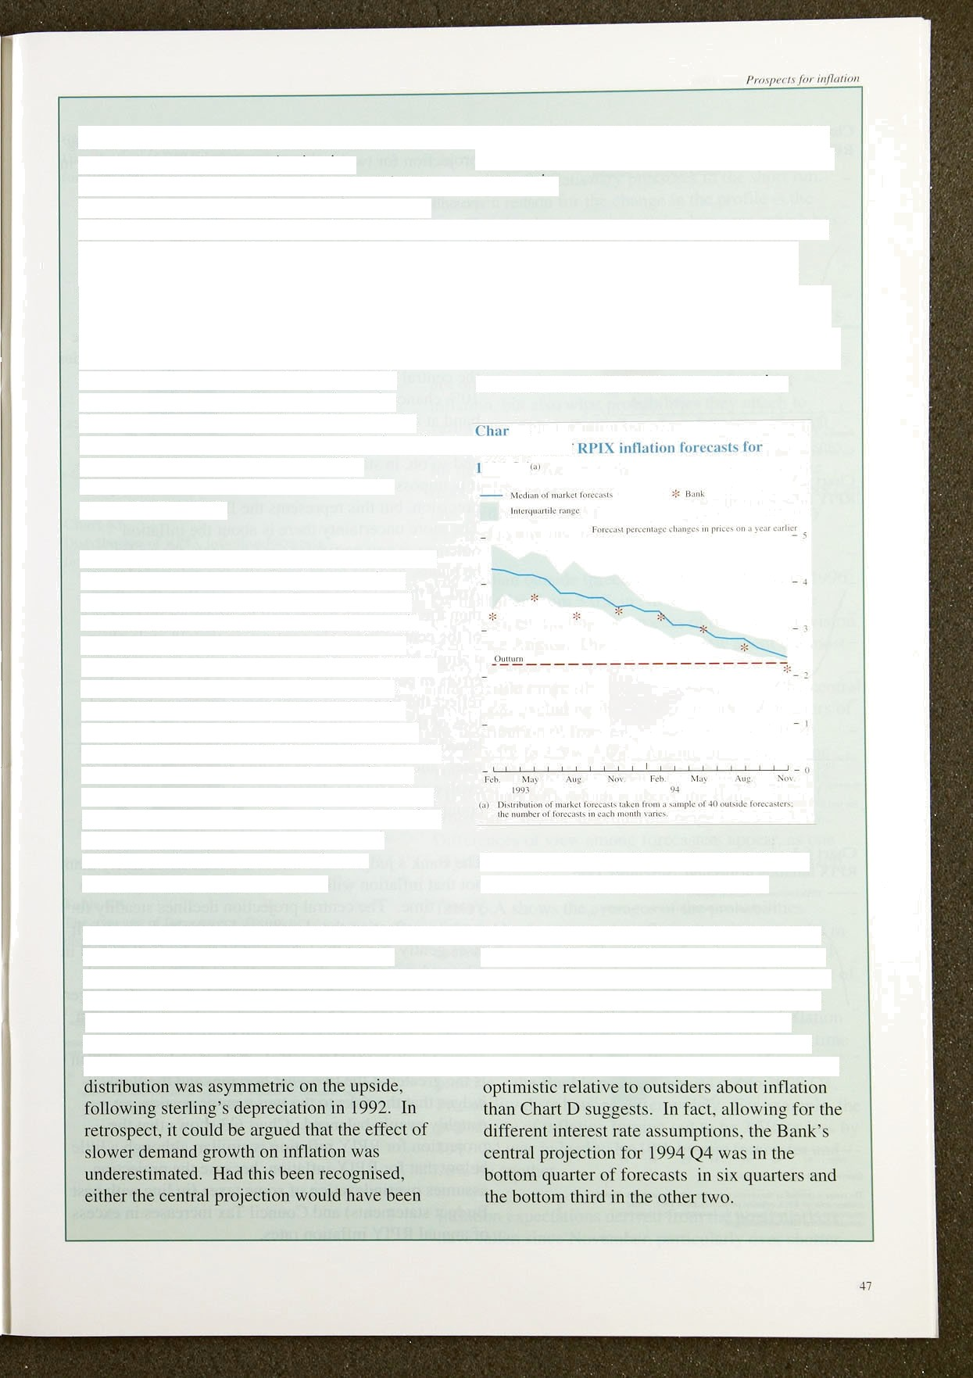

These considerations complicate the assessment of inflation forecasts. A simple comparison between the central projection and the actual inflation outturn will show that the forecast is almost always ‘wrong’. More sophisticated would be a comparison between the distribution of inflation outturns over a period, and the probability distribution which described the earlier projection. Over time. forecasts based

on the true probability distribution should not be biased in one direction or another, but it may take many years, or economic cycles. before an appraisal can be made. More relevant is the fact that the risks to any central projection of inflation derive from economic factors identified in the *Inflation Ref›nrt.*

So how were the uncertainties identified in the earlier *Inflation Reports* resolved with the passage of time? There are some clues. The central projection of inflation in the February 1993 *Report,* for example, proved too high, even though output growth was stronger than expected. Moreover, the projected probability

lower or the probability distribution around the central projection would have been more nearly

symmetric.

Similar comments could be made about central projections of inflation published later in

1993, although the differences between the central projections and the subsequent inflation outturns were smaller. Despite this, the

Bank’s projections from this period were closer to the eventual outturns than those of most other forecasters, as Chart D shows, suggesting

that the probability distribution for inflation used by the Bank was closer to reality.

And this comparison with outside forecasters does not adjust for differences in assumptions about interest rates over the period. The Bank assumed unchanged interest rates throughout the forecast period, while the majority of outside forecasts assumed that interest rates would be increased. The Bank was even more

In!1nti‹?ti Rep‹›rt: Fehr\ii\rs' I °Jg6

L'hart 6.2

**RPIX ii flatinn pro, ertion**

•'ourccs: £’ 8D aml fai0. ut' Eni tiiiiil.

see ice i i or e.xp *n:uiu» uf ihc coliiurcil fKndj

Chart 6..3

RPIY inflation projection

###### shown in Chart:.6.2. Chart:6.3

projection .for twelve-month **RPIY** inflation. Botil are in "' “ "”” 1 " • a new style, designe‹J to illustrate tlie distribution of



_ , possible outcomes of inflation ,over the! next two years,

The old style of chart—the No,vember projection is ' shown in Chart 6. focused too .much attention on

the central projection, whereas, as .the box on

_ pages 4 7 makes clear, any coherent projection is a probability distribution and not a point estimate..

The new chart shows the: relative likelihnod of possible outcomes. The central band, colouiedldeep red, includes.

_ the central projection: there is judged.to be about a 10% chance that inflation will be within that central.

•‹ • ••* " band at any date. The next deepest shade, on .both sides

of the central band, takes the distribution out to 20%; arid so on, in steps of ten percentage points. Of course, it is impossible to .assess the probabilities with any precision, but this represents the Bank’s best estimate.

Cbart 6.4

"”“" "" ’°• The more uncertainty there is about the inflation

outcome at any particular time horizon, the wider he bands, and the more gradually the colour fades.

And, if the risks are more on one side than the other,

* • then the remaining bands will be. wider,on.that..side!

, of the central band. .In contrast, in the. old-.style chart, a single band was shown corresppn‹iing to.average errors in past projections, which did not necessarily

* reflect the Bank’s judgment about the magnitude and bias of.the risks at the time. Charts ñ.2,and, 6.3,a based on the assqmption of unchanged official interest

•‹ '» *•* ' rates, and the effective exchange .rate is assumed to

evolve according to differences. i'n .interest rates across countries.

The Bank’s judgment is that it is a little more likely than

**RPIX** inflation **projection, November J995**



_ ActuJl







not that inflation will.be somewhat below 2'/ &o in two years’ time. The ce'ntral projection declines steadily for a while, reflecting the-slowdomn in activity last year. It rises.gently:clu:ring the latter p

a lagged response to the projected.pick-up:in nomi!nal demand this year. The rñairi tlownside risk is pf a longer delay than assumed lbefore activity picks .u.p. The main



.upside risk is that.the upturn will be stro*ger that

is:the greater!a:tithe:twe-year:horizon, and the B judges thgt the nsks.(o tire two-year projection are rougitly:eyeitiy'balanced. Chart 6.3 showa that’the

projmtioâ:.for RPIY inflati'on is st:nii1ar,..although a little

be!ow that.for RPIX inflation, **because** the prnjeciinn

,!âisqmes overindexation.of some;fanes (in,line with past

##### Bird.'get statements) .anñ”CouneilTñx in‹masm.ix ox of Annual RPIY i!nflation, rates-.





Cltart 6fi

**Dystribution of RPIX inflation forecasts**





**Chart fi.6**

**Distribution of RT•IZ inflation forecasts**

for 199J Q4







:0.0. 0.6 t2 "'I%'. ’’3$:/ JR ’’3Y..”.42. %,8 54’’:6O



**Table** €rA

**Tire average.:of.forecasters' frequency distrlbiitioy 9 expected .inttati.o. *!°'**

.Compared with the November projection shown in

.Chart 6.4, the new projection represents a downward reappraisal. of inflationary pressures in the short run. The.main reason for the change in the profile 1s the extent of the slowdown in .activity last year, which has become evident in the revised data released since November.

## Outside forecasters

* For the first time the Bank has asked outside forecasters not only about their central projections for RPIX inflation, but also what probabilities they attach to

, various possible inflation outcomes. This means that. just as for the Bank’s projection, it is possible to assess for the outside forecasts the size and direction of the risks. Differences of view among outside forecasters can thus be distinguished from the degree of uncertainty attached to any one forecast.

, The median outside forecast for **RPIX** inflation in 1996 Q4 has fallen from 3.0% in November to 2.8% (see Chart 6.5), continuing the process of downward revision seen since August. Differences of view about the most

'* likely inflation outcome—as represented by the interquartile range (thal is, the range spanning the central projections excluding the highest and lowest quarters of the disltribution of forecasts) have narrowed from 2.7%—3.5% to 2.5%—3.0%. Among the forecasts for 1997 Q4, the median expected RPIX inflation rate is 31.0&a (Chart 6,6), which is above the Bank’s central

* projection, and the interquartile range is 2.5%—3.39c. Differences of view among forecasters appear. as one might expect, to be greater the longer the time horizon.

Table 6.A shows the averages of the probabilities assigned by forecasters to inflation turning out to be in each of five ranges. The range of uncertainty around most forecasters’ central projections is similar to that of the Bank. They see more upside risk than the .Bank does, and, on average, think il less likely that inflation



" practice-the .Bank’s projection goes out to 1998 Q1.

###### Probability’.distri!butions differ widely. For example, the

.probability.of inflation turning.out to be 2.5to or less by 1997 Q4 was judged to be l0&c by one forecaster and 70no by another.

.Inflation expectations derived from the bond markets

•' ' ' ' **hitVeRlleti since lSio*ember,** pârticu!arly over shorter



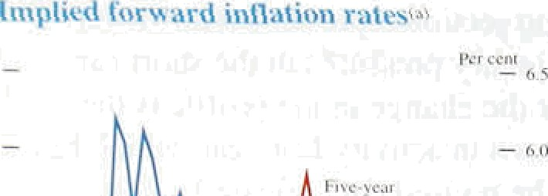t’ li:i ri f›.7 hori.zons—see.Chart 5.7, w.hich shows calendar-rfi nth

.iverages. This conceals the fact that since mid-January inflation expectations at both the fiv,e and ten.-year

.hot izons h‹ive risen by 0.35 pei’centage .points.

* 1. **COHCluSlOHS**

Retail price irritation was stable over the past three months, and iiiantifacturing output price. i!nflation fell. Domestically generated in.flation remains low, and the

°" “ " short-run outlook is for lower inflation than expected in the November *Re Perl,* with little or no sign of any imminent rise.

‹I . •J4 tñ •J I r

IN:1*J

Economic gi’owth slowed throughout last year. Non-oil

"" output in 1995 was about 2'/:% higher than in 1994. But the four-quarter gi’owth rate fell throughout the year fi’oni 3'/ °/c .at the beginning to .about l ’/ %. at .the end.

Since early 1995, output has been growing below almost an.y estimate of the trend, al.though this became evident only when revised data were published i.n November.

Any further fall in the growth rate is likely to be temporary, reflecting an unwinding of involuntary stockbuilding. But a more protracted period of slow

gi owth during 1996, as a result .of.si.gnificant downward revisions to growth prospects in the world economy (especially in France and .Germany), cannot be ruled out.

Looking further ahea‹i, .output growth is li!hely to pick up later this year and into next, led b.y accelerating consumption. Precisely when tfiat rñi hf happen, is unclear because of.the uncertainties to demand in the shon run. Continuing rapid broad money .growth

implies a more buoyant medium-term outlook for domesti.c demand. Real broad.money growth rose sharply from .1..7%, during I994 to. 6.9% in 199.5. Rising output growth would.at some point ’elim.inaie spare capacity, and would,. if unchecked...begin to lead !to. i.n.flationary pressures.,

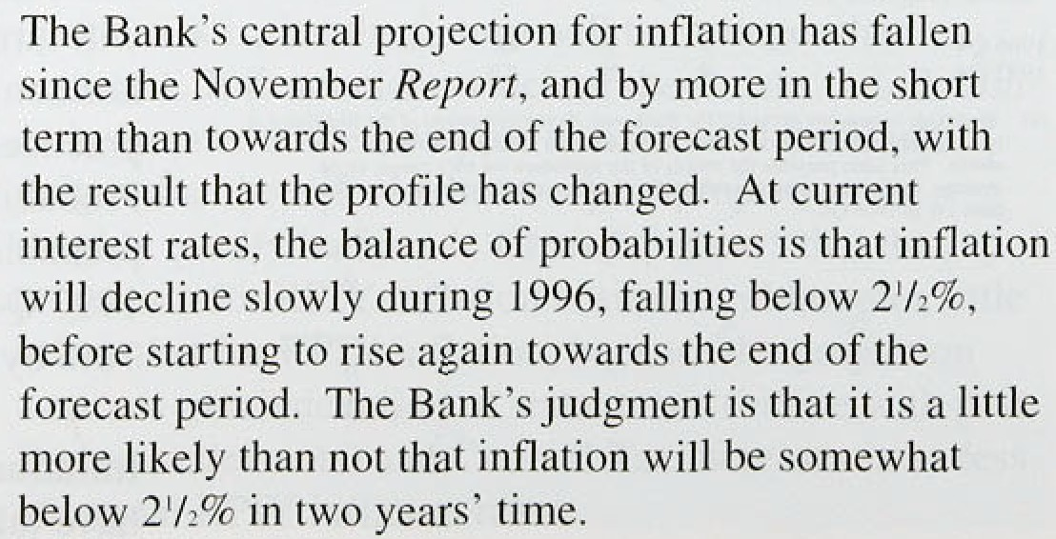

/’ /››y r' ‹ /.i /‹/i i i J?rr/ I ii

Some Of the uncerlainties discussed in the November *Reyort* have subsequentl y been. a1 least parti all y. resolved. Input price pressui es have ceased lo put upwurd pre.;.sure on outpul mid rctai) prices. There has been evidence or some rundown of’ stt›cks. In the short term, the principal uncertaintics concern activity, where the risks ure *more on* the ‹J‹iwiiside. Further t›ut. however, the main uncertaintie s relate to the implicatir›ns of broad money growth ‹ind the pace at which consumptit›n will pick up. Her e the risks are clearly i»oi’e on the upside. But it is too soon to tell it’, and when, faster money and nominal demand growth will threaten achievement of’ the int3atit›n target.

## Glossary and other information

###### Glossary of selected terms

**RPI inflation:** imation measured by the retail prices index: **RPIX inflation:** inflation measured by the.RPI.excluding mortgage interest.payments:

**RPIY** inflatuin: inflation measured by the .RPI excluding mortgage interest payments and the following indirect tnxes:

.council tax, VAT, duties, cnr purchase tax and vehicle excise duty, insurance. tax and ai.rport tax.

HARP index: a price index which replaces the mortgage .interest payments in the RPI with a Bank estimate of the user-cost of housing.

THAiu• index: the HARP irrdex excluding indirect taxes.

M0: notes and coin in circulation outside the Bank of England and bankers’ operational ‹deposits at the Bank.

M4: UK non-bank, non-building society private sector’s holdings of notes an‹i coin, together with all sterling deposits (including certificates of deposit) held with UK banks and building societies by the non-bank, non-building society private sector.

**Divisia** money: a measure of the money stock in which eacli component is weighted according to an estimate of how useful art the transaction services.it provi‹ies.

ICCs: industrial and commercial companies. OFIs: other financial institutions.

**Three-month annualized:** .the percentage:.change in: a series between one perioid and that.:three months:heartier,.expressed as an annual rate.

###### Symbols and coriventions

Except where otherwise stated, .the source.for ttie dam

used in charis and tables is the Central!Statistical .0ffice (CSO). The measures of inflatipn include‹i in. this *Report* have ñeen, adjusted by the Bank for a CSO error in underrecording,RPI and RPIX inflation between February and May 1995.

not available..

— nil or less. than.half the final di!git shown,

Because of rouiding„the. sum of the separate items‘ may

.sometimes..differ from th.e .to l s town:

!On. the honzontal,axes of graphs, larger! Nicks denote the .first observation within. the relevant period, eg.datn for:1ie.first quarter of .the year:

**Other information**



Price £3.00